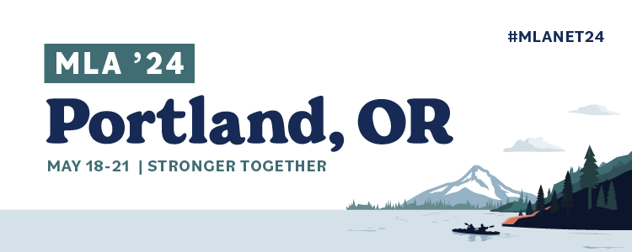

Immersion Session

The proposal overall is clearly communicated and organized.
3 - Agree | Proposal is clearly understandable and well organized.
2 - Neutral | The proposal is clear but could use additional information or editing to make it more understandable and organized.
1 - Disagree | Difficult to understand and disorganized. Not viable for MLA.

The session structure as described is appropriate and relevant to present for up to 75-minute time slot.

3 - Agree | Detailed agenda: potential speaker(s) identified or confirmed. Agenda and proposed times provided and realistic.
2 - Neutral | Agenda and proposed times provided but potentially unrealistic.
1 - Disagree | Lack of agenda. Limited speaker information. Mostly a collection of ideas.

The selected program format is appropriate for the content.
3 - Agree | Deep dive into a well-defined topic. Effective use of instruction methods and/or participant engagement using Immersion format. Participant engagement methods are appropriate based on learning outcomes.
2 - Neutral | Instructional methods and/or participant engagement could be more fleshed out.
1 - Disagree | Content needs more details and activity to fit Immersion format or topic is not a good fit for the Immersion program format.

The program will appeal to the target audience and target learner level.
3 - Agree | Target audience and learner level is clearly identified and applicable to the MLA Conference.
2 - Neutral | Target audience and learner level is identified but could be better described. May not be applicable to the MLA Conference.
1 - Disagree | No target audience identified or not applicable to MLA Conference.

The program description is interesting, inspiring, and/or addresses a relevant and timely idea, issue or need. The program addresses current MLA strategic goals or current topics/events/controversies in the profession.
3 - Agree | Description is interesting and describes a program that would appeal to or benefit MLA audiences. Includes evidence indicating member interest in the topic or would potentially be interesting, inspiring, and/or timely.
2 - Neutral | Description is light on details or doesn’t present a particularly timely idea, issue, or need to MLA audiences.
1 - Disagree | Description is broad and does not present a relevant or timely idea to MLA audiences.

The program description shows originality and innovation.
3 - Agree | The immersion proposal presents an entirely new idea or a new way of looking at a topic. It could be that the manner of presentation is novel or unconventional from what is usually at the MLA meeting.
2 - Neutral | Proposal focuses on an old(er) idea or concept but with a new lens/framework.
1 - Disagree | Proposal is covering a recently/previously covered topic with no new information or updates.

The learning outcomes of the program are specifically described.
3 - Agree | Outcomes are clearly listed, described, and actionable.
2 - Neutral | Outcomes are listed but need to be fleshed out.
1 - Disagree | No learning outcomes indicated.

**Reviewers: Include suggestions for how applicants can strengthen their submission in your reviewer comments.

