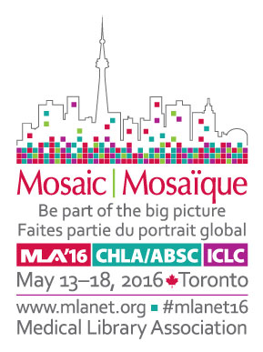

Mosaic 2016 Annual Meeting and Exhibition
e-Conference Site License

The e-conference site license enables your institution to provide online access to Mosaic ‘16 content for up to 25 staff. If you have more staff, additional site licenses (valid for 25 staff each) may be purchased. The cost for an MLA institutional member is $750. For non-MLA-institutional members the cost is $1,000.

The e-conference provides exclusive online access to Mosaic ‘16 content through May, 2017. Online access includes:

- Plenary Sessions, keynote McGovern lecture, Janet Doe lecture, business meetings, and Wednesday morning sessions via streaming video (available within 24 hours after the presentation)
- Section programs via audio recordings synchronized with PowerPoint presentations (available within 1 week after the meeting, to allow time for editing)
- 200 posters on a wide range of topics
- Abstracts
- Access to the online content the way you want on your PC, smart phone, or mp3 device

To register, complete the form on the next page and return with payment to:

Mail: | Credit Card Payments Only
Medical Library Association | Email: pacetti@mail.mlahq.org
65 E. Wacker Place, Suite 1900 | Fax: 312.419.8950
Chicago, IL 60601
Attn: e-Conference Registration

Terms: MLA agrees to provide exclusive access via Internet to meeting for up to 12 months after the meeting. By returning this registration form, the Site Licenses Holder agrees to safeguard and not make public passwords for access. Use of the meeting content shall be in conformity with applicable copyright laws. MLA shall do its best to deliver the programming listed above but shall not be liable for programming that is not available online due to circumstances beyond its control.

For questions contact Ray Naegele, naegele@mail.mlahq.org, phone: 312.419.9094, x17, or Tom Pacetti, pacetti@mail.mlahq.org, phone: 312.419.9094 x19

Mosaic 2016 Annual Meeting and Exhibition
e-Conference Site License Registration

For a site license, complete the information below and return with payment.

Circle appropriate fee: | Fee | Institution’s Member ID or Institutional Representative
MLA Institutional Member | $750
Non-MLA-Institutional Member | $1,000

Institution Site Name:
Contact person:
Institution (if different from site location):
Mailing address:
City/State/Zip code:
Telephone: Fax: Email address:
Payment: Check enclosed (payable to MLA) Visa MasterCard American Express Discover
Name on credit card: CC Number: __________________________ CSC: ________
Exp. Date (mm/yy): Signature:

List staff that will receive online access (please print clearly or include an attachment and check here ____):
 | Name | Email address to receive confirmation
1
2
3
4
5
6
7
8
9
10
11
12
13
14
15
16
17
18
19
20
21
22
23
24
25

Mail: | Credit Card Payments Only
Medical Library Association | Email: pacetti@mail.mlahq.org
65 E. Wacker Place, Suite 1900 | Fax: 312.419.8950
Chicago, IL 60601
Attn: e-Conference Registration

Questions, contact Ray Naegele, naegele@mail.mlahq.org, 312.419.9094, x17 or Tom Pacetti, pacetti@mail.mlahq.org, 312.419.9094 x19.

