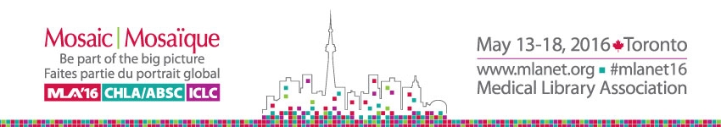

Chapter Council Presents: Sharing Roundtables
Sunday, May 15, 2016

Instructions for Facilitators
Benefits:
- Acting as a facilitator is a great way to learn more about a topic of interest and interact with your colleagues while earning one AHIP point. An AHIP letter will be sent to each facilitator after the MLA Annual Meeting.
Preparation:
- Come with a list of discussion questions or ideas to be discussed.
- Bring handouts to share with roundtable members (optional).

During Roundtable:
- Begin with introduction of table participants and an overview of the topic.
- Circulate the two Attendance Sign-In Sheets (sheets will be provided at the luncheon, no need to bring).
- Initiate discussion and encourage participants to share their ideas, experiences, and concerns.
- Guide the discussion. Keep it lively and moving throughout the session
- Encourage the quieter members to share their ideas, experiences and concerns.
- Please encourage attendees at your table to complete the online Evaluation Form, available on the Chapter Council website: www.chaptercouncil.mlanet.org/roundtables/index.html.

At the End:
- Leave Attendance Sign-In Sheet on the table to be collected by a Chapter Council member. You may keep the second copy for your records.

