April 2019
Prepared by the Joint MLA/AAHSL Legislative Task Force
For further information, contact Mary M. Langman at (312) 419-9094, ext. 27
Online Version: https://www.mlanet.org/p/cm/ld/fid=201

The National Library of Medicine: A Platform for Biomedical Discovery and Data-Powered Health
The National Library of Medicine (NLM) plays an essential role in catalyzing basic biomedical science and data-driven discovery through its cutting-edge research, information systems, collections, and training programs. NLM acquires, organizes, curates, and delivers up-to-date biomedical information across the United States and around the globe, and its electronic information sources are used millions of times each day. NLM makes research results available for translation into new treatments, products, and practices; provides decision support for health professionals and patients; and aids disaster and emergency preparedness and response. In partnership with other parts of the National Institutes of Health (NIH) and other federal agencies, NLM is a key link in the chain that translates biomedical research into practice, making the results of research readily available worldwide. The NLM Strategic Plan 2017-2027, A Platform for Biomedical Discovery and Data-Powered Health, positions NLM as a platform for biomedical discovery and data-powered health through the provision of tools for data-driven research, reaching more people in more ways through enhanced dissemination and engagement pathways, and building a workforce for data-driven research and health.
Because NLM is an investment in good health; because its resources serve the public, care providers, and researchers; and because NLM is a leader in global disaster preparedness and response support, the Medical Library Association (MLA) and Association of Academic Health Sciences Libraries (AAHSL) urge Congress to increase funding levels to at least $457.4 million(+15.5 million), a 3.5 percent increase for NLM in Fiscal Year (FY) 2020, and to increase NIH funding levels to at least $41.6 billion (+$2.5 billion), a 6.4 percent increase, including dedicated funding provided to the Agency through the 21st Century Cures Act.

NLM Resources Serve the Public, Care Providers, and Researchers

NLM makes almost 300 databases and online services freely available through libraries and to anyone with Internet access. These resources support health care, public health, disease prevention and wellness, biomedical research, and innovation. They can be accessed at https://www.nlm.nih.gov/.

NLM’s most heavily used resources are:

NLM Website | Key Statistic | Other Information
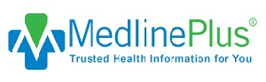  https://medlineplus.gov | More than 695 million pageviews from 277 million users annually | - Consumer health information  - More than 1,000 health topics in English and Spanish and more than 130 lab test pages  - MedlinePlus Connect links to consumer information from patients’ EHRs. NLM fulfilled more than 156 million queries.
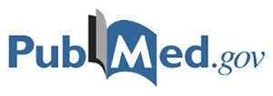  https://www.ncbi.nlm.nih.gov/pubmed | More than 29.1 million journal citations | - Citations from MEDLINE, life science journals, and online books  - Searched by 2.9 million users each day

NLM Website | Key Statistic | Other Information
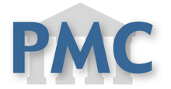  https://www.ncbi.nlm.nih.gov/pmc | Free access to more than 5.1 million articles on PubMed Central | - On a typical day, more than 2.5 million users download more than 5 million articles  - Congressionally mandated NIH public access policy has added 1 million articles, which have been viewed more than 1 billion times  - Supports public access policies of 10 other Federal agencies  - Coordinates with publishers and authors to make supporting datasets available or discoverable directly from the literature.
https://nnlm.gov | 7,100 members in communities nationwide | - Trains medical librarians, health professionals, and the general public to use NLM resources and services  - Outreach to public libraries, secondary schools, senior centers, etc., and underserved populations  - Collaboration with NIH’s All of Us initiative to engage local communities, raise awareness, and improve health literacy.
https://clinicaltrials.gov | 287,000 clinical studies in all 50 states and in 208 countries | - World′s largest clinical trial registry and results database  - Results posted for more than 33,000 studies  - More than 116,000 different users each day
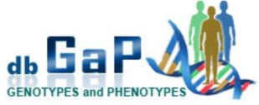  https://www.ncbi.nlm.nih.gov/gap | More than 1,100 studies involving more than 2 million people | - Connects genomic data with physical characteristic and clinical information  - Provides access to summary-level genomic results from most NIH-supported genomic studies.
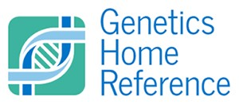  https://ghr.nlm.nih.gov | 1.9 million visitors per month | - Consumer-friendly health information  - Basics of human genetics  - Information on more than 1,200 genetic conditions and 1,400 genes

The Medical Library Association (MLA) is a nonprofit, educational organization with 3,500 health sciences information professional members worldwide. Founded in 1898, MLA provides lifelong educational opportunities, supports a knowledgebase of health information research, and works with a global network of partners to promote the importance of quality information for improved health to the health care community and the public.

The Association of Academic Health Sciences Libraries (AAHSL) supports academic health sciences libraries and directors in advancing the patient care, research, education, and community service missions of academic health centers through visionary executive leadership and expertise in health information, scholarly communication, and knowledge management.

