Improving Access and Use of HINARI Resources by Health Professionals in Vietnam: Report
Co-PI: Irena Bond, MCPHS University and Nguyen Hi Ha, Hanoi University of Public Health (HUPH)
The Co-PIs developed and delivered 9 HINARI/Research4 Life training workshops to health science faculty, librarians, students, clinicians and researchers in Vietnam in October 2018. Specifically this program uniquely targeted Pharmacy/Pharmacology/Pharmacognosy faculty and clinicians. The program was collaboration between the Massachusetts College of Pharmacy and Health Sciences (MCPHS University), Hanoi University of Public Health (HUPH), and Hue University of Medicine and Pharmacy (HUMP) and their libraries. The project was funded by $6000 Librarians without Borders (LWB) grant in 2016.
MCPHS University is one of the oldest institutions of higher education and in pharmacy in the US. The university offers more than 100 innovative programs in a wide range of health care fields. MCPHS University is committed to developing collaborations around the world and supports many successful programs in Asia, Latin America and Europe. MCPHS University has had established strong relationships with HUMP. There are established clinical rotations for pharmacy students and previous and existing joint program development.
The HUPH was established in 2001 and is the first institution in Vietnam to provide training in the field of public health. It has spacious facilities, advanced curricula and learning programs in Medicine, Community-based Nursing, Behaviors and Health Education, Environmental and Occupational Health, Fundamental Sciences. HUPH Library has open space and serves over 2,000 HUPH staff, students, and researchers working in the field of public health across the country.
The HUMP was established in 1957 and has grown through its international relationships. The University has been supported and funded by 30 international projects. The vision and strategic plan of the University is to become the national leading university; strongly focus on developing high quality training program and joint training program; improve the capacity of doing scientific research and applying technology. The Hue University Library and computers were utilized for the workshops.
The goal of the program was to improve access and use of HINARI and other health resources by raising participant’s awareness, abilities, and confidence with finding and using scientific research and clinical resources available to them. The project aimed to customize existing HINARI training modules, update the Evidence-based Medicine (EBM) module, and develop new Drug Information Resources module not currently available. This project modules are available on the World Health Organization (WHO) web site https://www.who.int/hinari/en/ and used by HINARI trainers around the world. The project also identified needs for potential training on open access educational technologies and resources as some institutions do not have continuous access to HINARI and there are often issues with accessing full text via HINARI. Workshops included both didactic and hands-on skill-building sessions in computer training rooms utilizing active learning approaches. These updates and enhancements allowed for a truly engaging program and strengthened the current HINARI training modules.
Future directions: With the remaining funds of the grant we are planning a visit for the HUPH Library director to MCPHS University for information/training exchange in 2019. We are also developing closer relationships with HUMP Library Director inviting her to join the Medical Library Association (MLA), the MLA International section, and to visit MCPHS University and an MLA conference. We are also exploring the opportunity to apply jointly for another LWB grant and expand the training program in both HUPH and HUPM and the National Institute of Malariology, Parasitology and Entomology (NIMPE), Hanoi.
Workshops at the Hanoi University of Public Health (HUPH) 10/15/2018, 8am-12:00pm
Participants: 25 faculty, librarians, clinicians, students, researchers from HUPH and other institutions
- Health Information Resources on the Internet – 2 hour workshop including discussion on grey literature, open access, journal article retraction, health organization sources – inter-governmental, governmental, and non-governmental agencies, searching and discussion tools: databases and library catalogs, search engines and gateways, discussion groups, e-Journal resources, EBM resources. A handout on additional open educational technologies, developed by Shanti Freundlich, Associate Director of Library Assessment and Online Learning at MCPHS University, was distributed to participants. | 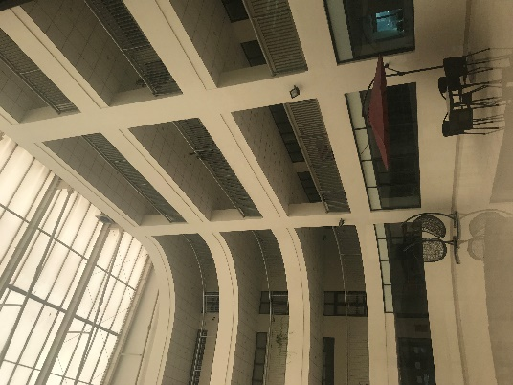
 | HUPH Library

- Basic and Advanced PubMed Searching – a 2 hour PubMed workshop including discussion on indexing and Medical Subject Headings (MESH), search details, basic and advanced searching using Boolean operators, search history, applying filters, and finding full text. | 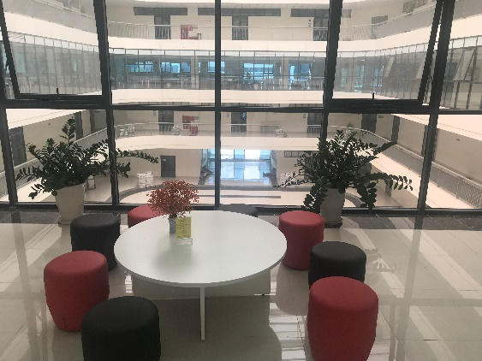
 | HUPH Library

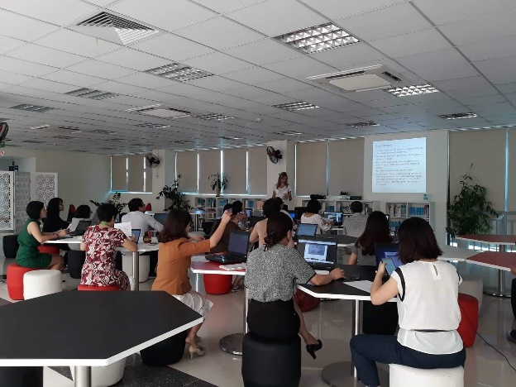 | Workshops at HUPH were attended by 25 faculty, librarians, clinicians, students and researchers from the following HUPH departments: Library, Health Policy, Social Sciences, Health Rehabilitation, Nutrition, Health Management Training, Public Health, Clinical and Laboratory.  Participants from other institutions included Hanoi University of Medicine, Center for Public Health and EcoSystem Research, and the local Military Hospital.
Workshops at the HUPH Library

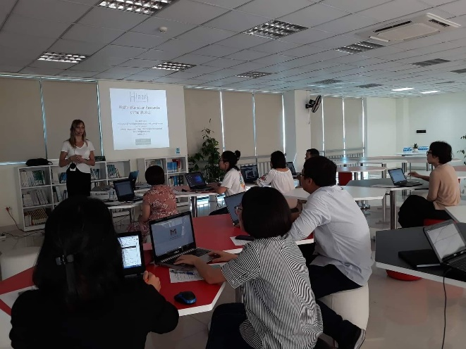 | 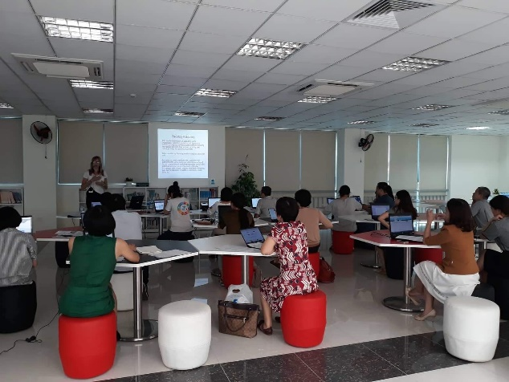
Workshops at HUPH
Outcomes/Lessons Learned: Participants shared that they benefited from the PubMed instruction a lot and from instruction on how to find international research articles. Specifically, they liked the advanced PubMed searching and finding full text through open access. They were surprised to learn about predatory journals and article retraction. They had additional questions on copyright and how to use articles in teaching. Additional instruction on open access resources and educational technologies will be beneficial.

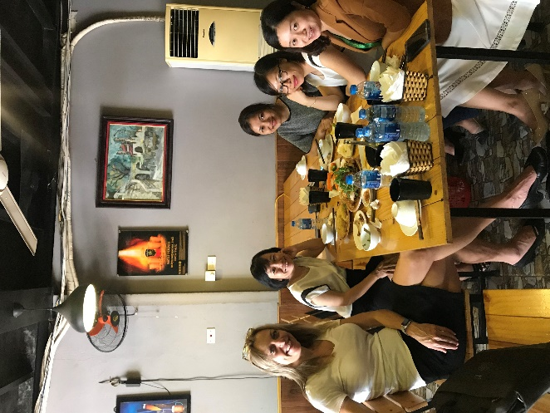 |  | 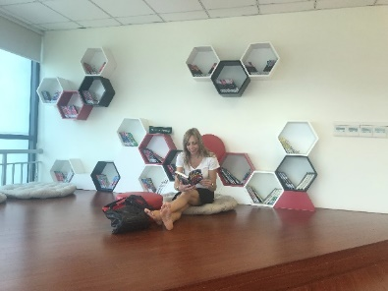
 |  | 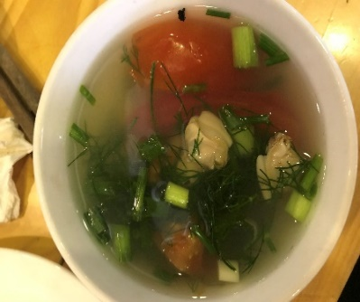
Midday lunch break with librarians featuring traditional Vietnamese food and a motorbike ride back with a librarian to HUPH followed by a tour of the HUPH library.

Workshops at the National Institute of Malariology, Parasitology and Entomology (NIMPE), Hanoi, 10/16/2018, 1-5pm
- Evidence-based Medicine: Finding the Evidence-2 hour workshop with focus on EBM definition, organization of the medical literature in primary, secondary, tertiary resources, EBM process, and EBM search approaches  - EBM Resources: 2 hour introduction and demo to the Cochrane Library  PubMed, Essential Evidence Plus, EBM Journals, Other EBM Internet Resources  20 researchers and clinicians attended the workshops. | 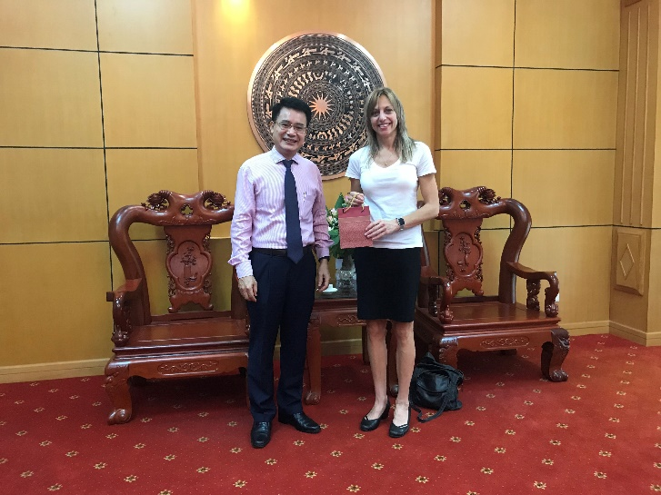

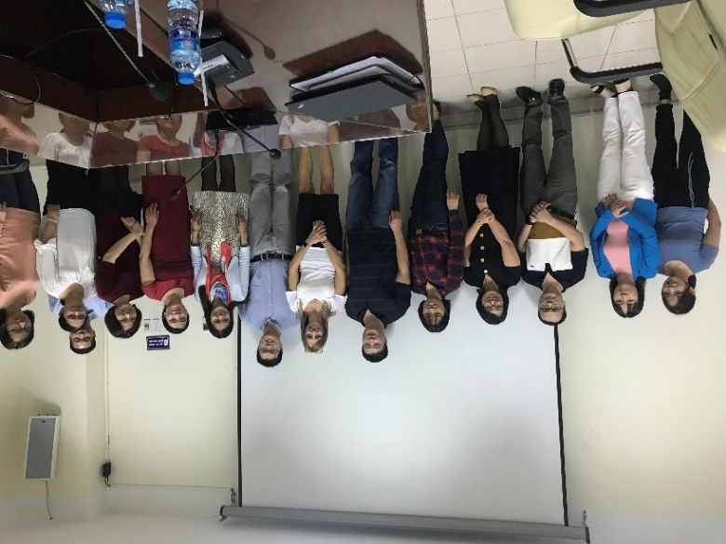
Workshops at NIMPE
Outcomes/Lessons Learned: Particpants had many insteresting qiuestions about qualitative and small scale research from developing countries and EBM, publishing process and how to get published, publishing opportunities for researchers from developing countries, finding full text, using open access resources. They found Pubmed session to be very useful and one of them said “She finally learned how to search PubMed” after previously attending other PubMed workshops.

Hue University of Medicine and Pharmacy (HUMP), Hue, 10/18/2018, 8am-5pm
Participants included: 14 librarians, 15 Pharmacy faculty, and 58 Medical and Pharmacy students
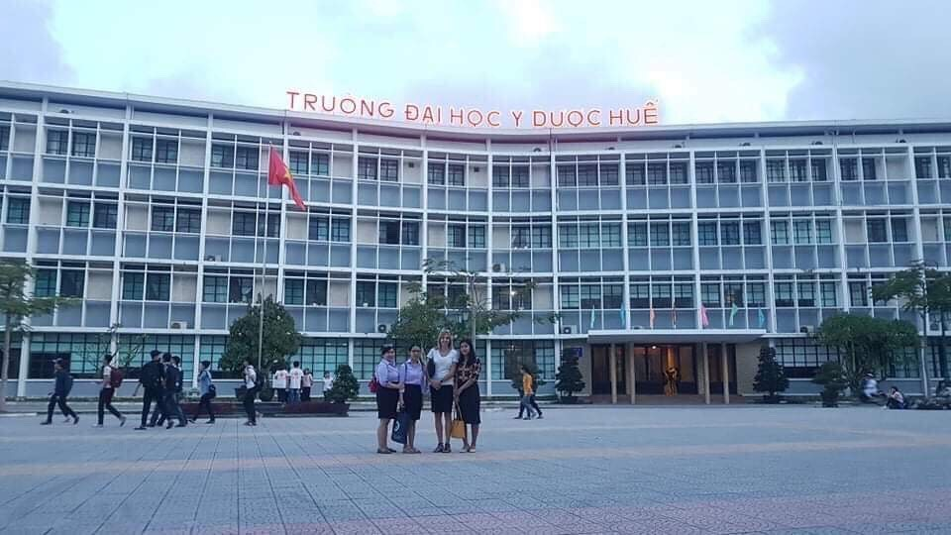 | 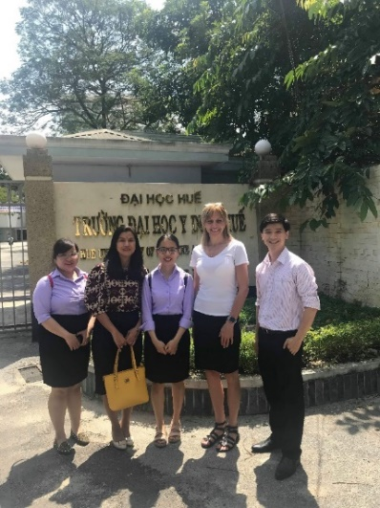
With librarians at the HUMP campus

- HINARI resources- 1.5 hour workshop on access and use of HINARI e-books, e-journals, and other free resources | 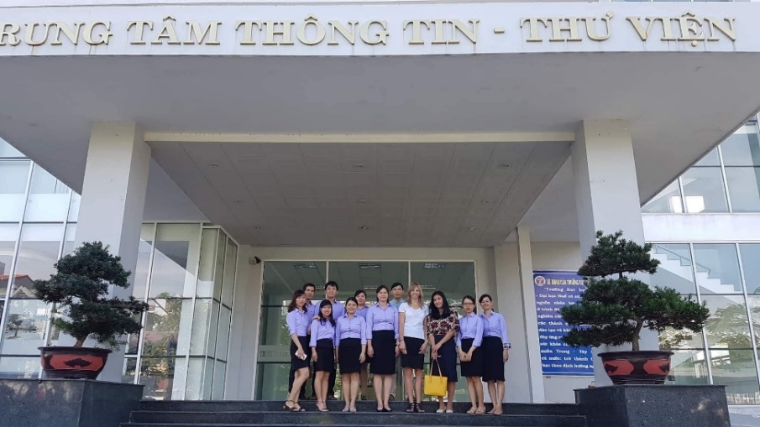
 | With Library Director and Librarians in front of the HUMP Library

- Basic and Advanced PubMed Searching for Medical and Pharmacy Students – 2 hour translated PubMed workshop including discussion on indexing and Medical Subject Headings (MESH), search details, basic and advanced searching using Boolean operators, search history, applying filters, and finding full text. |  | 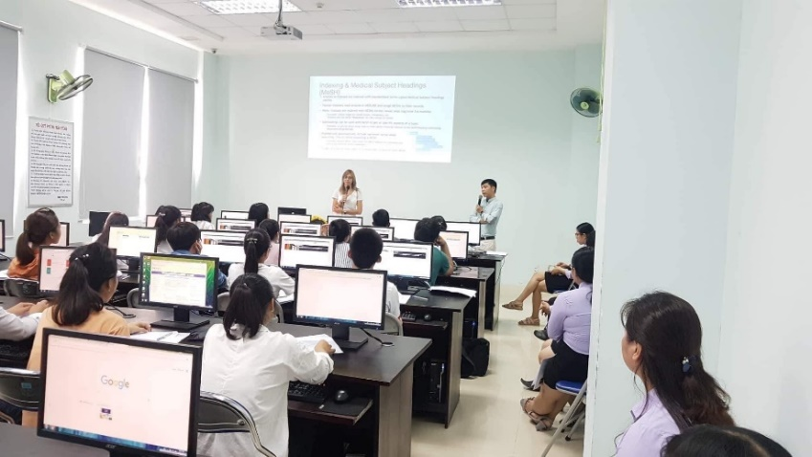
 |  | Workshops with medical and pharmacy students and librarians
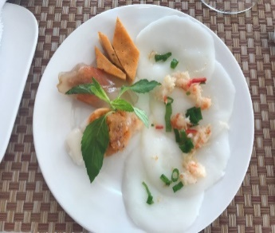 | 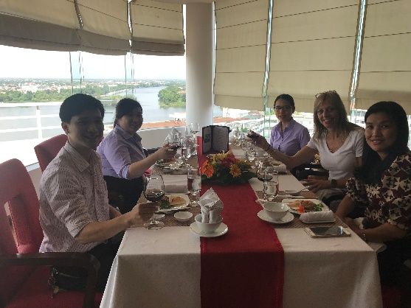 |  | 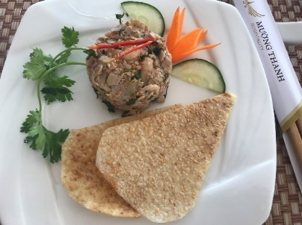
Lunch with Library Director, librarians, and faculty from the Department of Pharmacognosy, Traditional Pharmacy, and Botany at HUMP

- Evidence-based Medicine: Finding the Evidence – 2 hour workshop focused on EBM definition, organization of the medical literature in primary, secondary, tertiary resources, EBM process, and EBM search approaches  - EBM Resources- 2 hour introduction and demo on the Cochrane Library  PubMed, Essential Evidence Plus, EBM Journals, Other EBM Internet Resources | 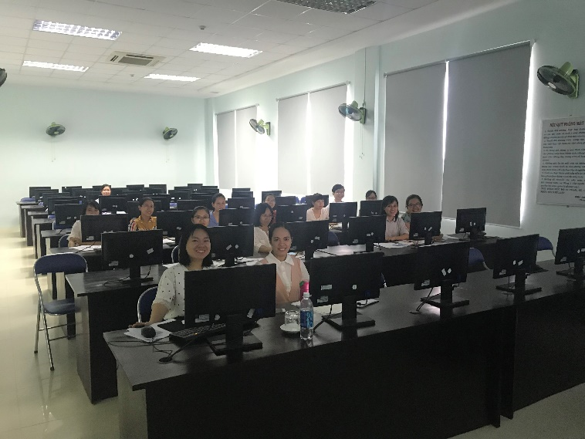
 | Workshop with Pharmacy faculty and librarians

- Drug Information Resources-1 hour introduction to Drug Information resources via HINARI, WHO and Other Free Quality Drug/Herb/Toxicology resources for professionals and consumers, including resources for special populations-pediatrics, geriatrics, pregnancy and lactation, and liver induced cases. | 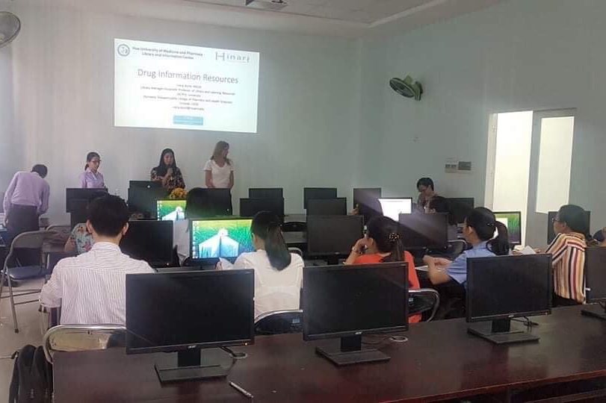
 | Workshop with Pharmacy faculty and librarians

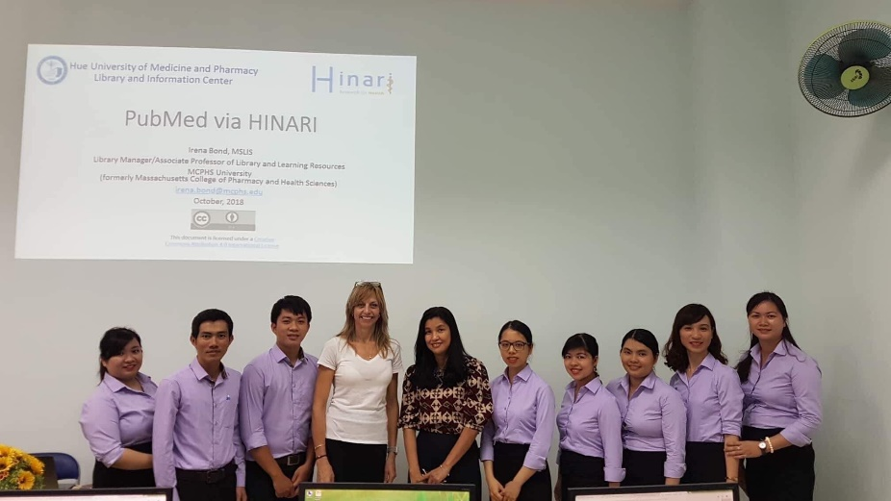 | 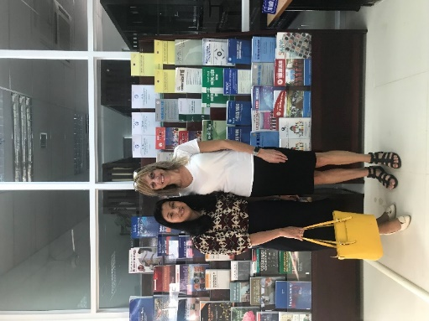
With HUMP Librarians | With HUMP Library Director

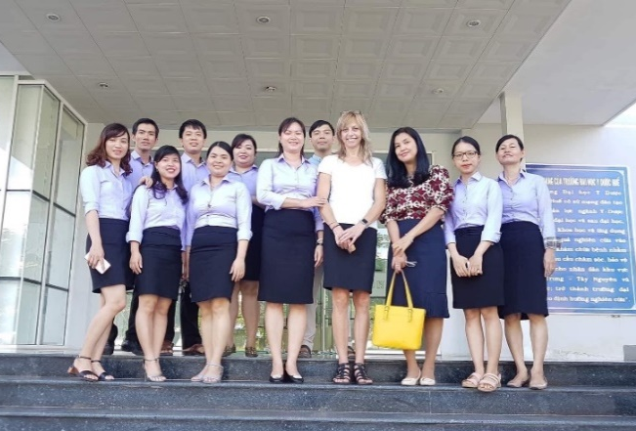 | 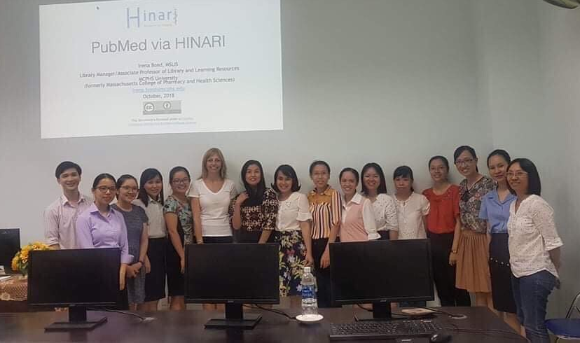
With HUMP librarians | With HUMP Pharmacy faculty

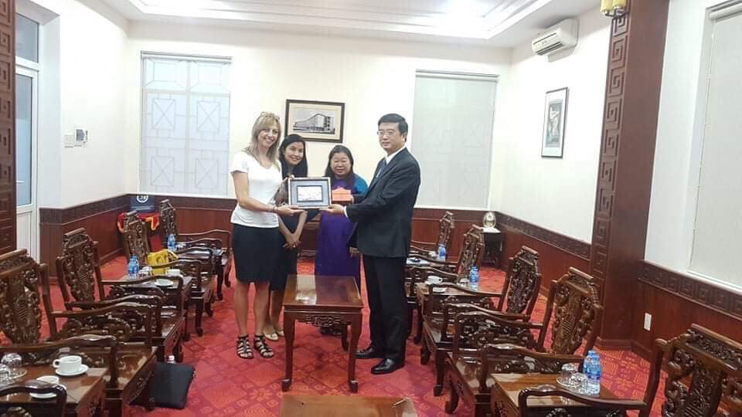 | The day ended with a formal meeting with Dr. Nguyen Vu Quoc Huy, HUMP Rector and Associate Professor of Obstetrics and Gynecology and Dr. Nguyen Thi Anh Phuong, Deputy Head, Office of Science –Technology and International Relations and Vice Dean, Faculty of International Education.
Receiveing an official HUMP plaque
Lessons Learned/Outcomes: Libraians really benefited from the Pubmed training. They said “we learned so much in a short time.” Pharmacy faculty enjoyed the focus on drug infromation resourecs and the clinical examples using drug infrormation questions to demo in databases. The herbal/alternative medicine portion of the training was also well received. They were entusiastic to receive more and more advanced training and very interested in future and expanded collaborations and training.

