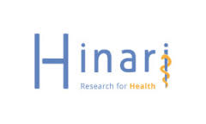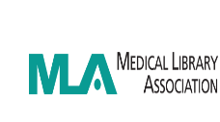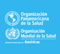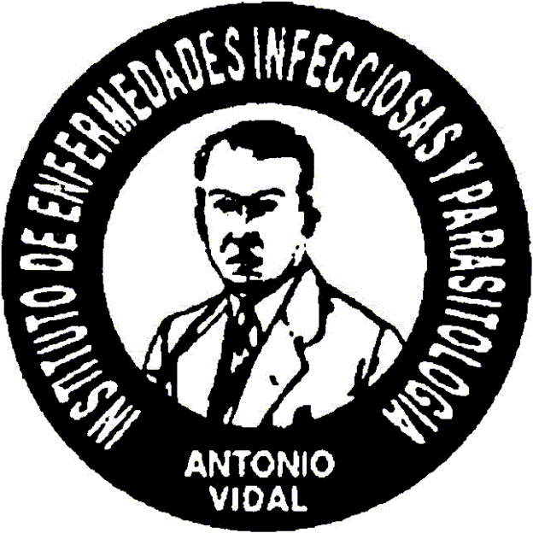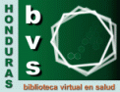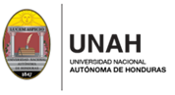
FINAL REPORT
PROJECT: E-LIBRARY TRAINING AND ACCESS ENHANCEMENT TO RESEARCH FOR HEALTH RESOURCES, NATIONAL AUTONOMOUS UNIVERSITY OF HONDURAS, 2016-2018.
Presented by: Martha Cecilia Garcia. National medical library. Universidad Nacional Autónoma de Honduras.
Responsible:
Martha Cecilia Garcia, Ovidio Padilla, Sandra Barahona, national medical library; National Autonomous University of Honduras (UNAH).
Jackeline Alger, unit of scientific research, Faculty of medical sciences; (UNAH), Institute of infectious diseases and Parasitology Antonio Vidal
Lourdes Ramírez, knowledge management and communications centre, Honduras PAHO/WHO representation.
EXECUTION period: August 2016 - February 2018

ACTIVITIES DEVELOPED 2016
1. the 24 of August 2016 was confirmed to us the selection and approval of grant of $6,000 to develop the project.
2 due to problems in the reception of the funds allocated, modified the schedule established for the training. However, it is advanced in 2016 with local workshops and funded by institutions:
a workshop: HINARI/Research4Life resources and publication in health regulations. Carried out in the Central American technological University (UNITEC), September 2nd from 8:00 am to 4:30; with funds provided by the University, it was attended by 29 participants between teachers, students and researchers, inaugurated the workshop the Dean of the Faculty of Health Sciences, was reactivated your access key and is on track for another visit
b. September 20 Autónoma de Honduras (UNAH), the workshop was held "HINARI-CITAVI" within the framework of the XXIII scientific day and X Congress of research in the health sciences, of the Faculty of the National University Medical Sciences from 8 to 12 and from 1:00 to 4:00 PM. With the participation of students, teachers and researchers of the Faculty of medical sciences, Hospital, school, University, Faculty of dentistry and Department of health.
c. December 3 was the HINARI workshop for doctors in social service, the Faculty of medical sciences of the UNAH, with the objective of maximizing the use of resources of information HINARI, lasting 4 hours, 23 participants was attended by.
d. December 7, was held the workshop resources of information in health: HINARI, aimed at authors/researchers who published in the journal of the Faculty of medical sciences, the editor Board of the journal supported for materials and refreshments, attended by 27 participants. The objective is to use information and increase the number of research and publications in the journal.
e on December 8 was the workshop resources of information in health: HINARI, for authors/researchers who publish in the magazine, the journal of forensic sciences who supported for materials and refreshments, attended by 22 participants. This magazine is the Director of forensic medicine of the Public Ministry of Honduras. The objective is to use information and increase the number of research and publications in the journal.
f December 13 was held the workshop knowing HINARI, addressed students of graduate school of the Faculty of medical sciences of the UNAH, 20 participants was attended by. The objective support with HINARI information, so that they can conduct their research and publish at least 1 item to graduation and thus improve the ranking of the University.

ACTIVITIES DEVELOPED 2017
1. Workshop "information HINARI/RESEARCH4LIFE resources: training of trainers, aimed at librarians, 23 and 24 February held in Tegucigalpa, national medical library with 19 participants from different institutions." (Sent report)
2. Workshop "of information HINARI/RESEARCH4LIFE resources: training of trainers, at Universidad Nacional Autónoma de Honduras of the Valle de Sula (UNAH-VS) 29 and 30 March in San Pedro Sula, aimed at librarians in San pedro Sula and La Ceiba city." 20 participants from different institutions. (Sent report)
3. " Participation with" workshop: HINARI: health information resource"in the course of writing scientific articles" under the coordination of the Editorial Council of the journal of Faculty of medical sciences of the UNAH. Aimed at members of the editorial of the journal of the school of Health Sciences and researchers of the UNAH-VS. Held in San Pedro Sula in March 31, 2017.
4. With workshop participation: "bridging the gap of knowledge between PAIISES: RESEARCH4LIFE, HINARI", in the "II Congreso Universitario"Integrating knowledge for future professionals in health"Health Sciences. " In Tegucigalpa, City University may 3, 2017. Students UNAH, Catholic University, UNITEC, Universidad Pedagógica Nacional: 21 participants.
5. The national medical library in conjunction with the Association of librarians and documentalists of Honduras (ABIDH), developed the workshop "knowing the HINARI/Research4life information resources" at the National Pedagogical University Francisco Morazán (UPNFM) of San Pedro Sula, Honduras. Aimed at librarians, teachers and researchers from UPNFM and other institutions in San Pedro Sula, conducted July 14, 2017, with 34 participants.
6. Workshop HINARI resources: RESEARCH4LIFE for researchers. Aimed at school of dentistry and health staff. Tegucigalpa, national medical library. 10-11 August of 2017. Available at: http://www.bimena.bvs.hn/taller-citavi-research4life/; http://www.bimena.bvs.hn/taller-research4life/
7. Presentation of work free " HINARI: information for health research in the field of infectious diseases: experience in HONDURAS ', in the XIII Congress Central American and the Caribbean of Parasitology and Tropical Medicine . 22 to 26 August 2017 Tegucigalpa. Available at: http://www.bvs.hn/RMH/pdf/2017/html/Vol85-S2-2017.htm
8. Stand promotional of the HINARI RESEARCH4LIFE resources, in XIII Congress Central American and the Caribbean of Parasitology and Tropical Medicine. 22-26 August 2017.
9. Stand promotional HINARI RESEARCH$ LIFE resources. In Congress of Gastroenterology. Tegucigalpa 30 and August 31, 2017.
10. Workshop HINARI:RESEARCH4LIFE . Held in Tegucigalpa in the facilities of the Hospital Mary, directed to medical personnel of the Mary Hospital, institution registered with HINARI. September 17, 2017. 22 participants. Available at: http://www.bimena.bvs.hn/taller-recursos-de-informacion-research4life/
11. Workshop prejornada of the medical scientific conference XXIV: information resources on health, HINARI/CITAVI. 21 September 2017.
12. Presentation of work free "HINARI: information for the research in health: experience in HONDURAS" in the scientific conference XXIV and XI Congress of research in the health sciences. Tegucigalpa September 27-29, 2017. Available at: http://www.bvs.hn/RFCM/pdf/2017/html/RFCMVol14-S-2017.html
13. Promotional stand resources HINARI:RESEARCH4Life in on the scientific conference XXIV and XI Congress of research in health sciences. Tegucigalpa September 27-29, 2017
14. Workshop HINARI resources: information for research. 18 October 2017. Tegucigalpa: Medical library national, aimed at students, librarians and researchers of the Faculty of medical sciences. 25 people
15. Stand promotional resources HINARI RESEARCH4LIFE, VI Multidisciplinary Congress of the graduate of the Faculty of medical sciences of the UNAH. Tegucigalpa, 24-26 October of 2017.
16. Workshop HINARI:RESEARCH4LIFE: information for research University national Autonoma of Honduras of the Valley of Sula (UNAH VS) 25 and 26 October in San Pedro Sula led librarians from San pedro Sula and La Ceiba. City 25 participants.http://www.bimena.bvs.hn/taller-research4life-san-pedro-sula-25-y-26-de-octubre-2017/
17. Meeting for the Network of centers of information HINARI:RESEARCH4LIfe, national medical library, November 29. Participation of 15 participants from UNAH, Catholic University of Honduras and UNITEC. Presence of the DRA. Jackeline Alger Coordinator of the VHL-HN and representative of Institute Antonio Vidal, and the engineer Lourdes Ramirez, the national representation of the OPS. Available at: http://www.bimena.bvs.hn/reunion-de-centros-hinariresearch4life/
18. Training lectures: 61 available at: http://www.bimena.bvs.hn/taller-recursos-research4life-3/; http://www.bimena.bvs.hn/taller-recursos-research4life-2/; http://www.bimena.bvs.hn/taller-recursos-research4life/
19. Creation of an Individual authentication system by masking the Research4life resources, integrated in VIRTUAL classroom RESEARCH4LIFE.
20. Supported national institutions in: enrollment resources research4life, by problems with code and password; updating data and managers, between allasMencionamos: library UNAH, Faculty of dentistry UNAH, Maria Hospital, Ministry Public library Universidad Católica de Honduras, library National Pedagogical University Francisco Morazan, library Universidad José Cecilio del Valle, library University Valley of Sula in San Pedro Sula, CRAI in the technological University (UNITEC) , Centro de Cancer Emma Romero Callejas, San Pedro Sula Christian University Library.
21. As an activity linked, was carried out: the so-called workshop "use advanced search tools in the source Virtual HINARI" from 25 to 27 April 2017, in Managua, Nicaragua, brought together 41 representatives of different institutions of Nicaragua assigned to HINARI, including librarians, responsible for units of information, staff of the Ministry of health and hospitals accredited in this country. Available at: http://www.bvs.hn/RFCM/pdf/2017/html/RFCMVol14-1-2017.html
22. Promotional materials: Banner, brochures, books separators
23. For promotion links in the pages about the project and the activities were published. Available at: http://www.bimena.bvs.hn/la-biblioteca-medica-nacional-de-honduras-realiza-actividades-para-mejorar-el-acceso-a-los-recursos-de-informacion-hinariresearch4life/

ACTIVITIES JANUARY - FEBRUARY 2018
1. Workshops 2 - hours: 9, in March: 12.
2. Publication of the article "HINARI health research information: experience in Honduras." Martha Cecilia García, Ovidio Padilla, Lourdes Ramírez, Jackeline Alger"in the magazine of the Faculty of medical sciences of the Universidad Nacional Autónoma de Honduras 2017, Vol. 14 No. 2. Available at: http://www.bvs.hn/RFCM/pdf/2017/html/RFCMVol14-2-2017.html
3. Support institutions to carry out the registration and payment to Research4life

CONCLUSIONS:
1. The proposed project objectives were achieved at 100%
2. Training activities were higher than the proposed number, given the dedication of the work team and the collaboration of the institutions involved.
3. Knowledge of the Research4life resources was wide in the 3 proposed cities, and has been the multiplier effect at several institutions in Tegucigalpa and San Pedro Sula.
4. Was excellent the receptivity in the institutions to participate in trainings and always were very interested in the content participants.
5. Programming established in the project was modified, different situations, problems in the reception of funds, internal problems in the institutions by student strikes, bad weather prevailing in the northern part of Honduras; however the proposed workshops were developed and expanded the number of them as you can verify in the report.
6. Strengthened the national medical library for the development of a greater number of training and promotional activities, giving some accessories and basic equipment that would allow the development of the activities.
7. Next article will be published in the magazine the school of Sciences of health, no. 1; 2018 will be posted in June 2018

FINANCIAL REPORT
I. Annexes
CONFERENCES:
Presentation of work free " HINARI: information for health research in the field of infectious diseases: experience in HONDURAS ', in the XIII Congress Central American and the Caribbean of Parasitology and Tropical Medicine.
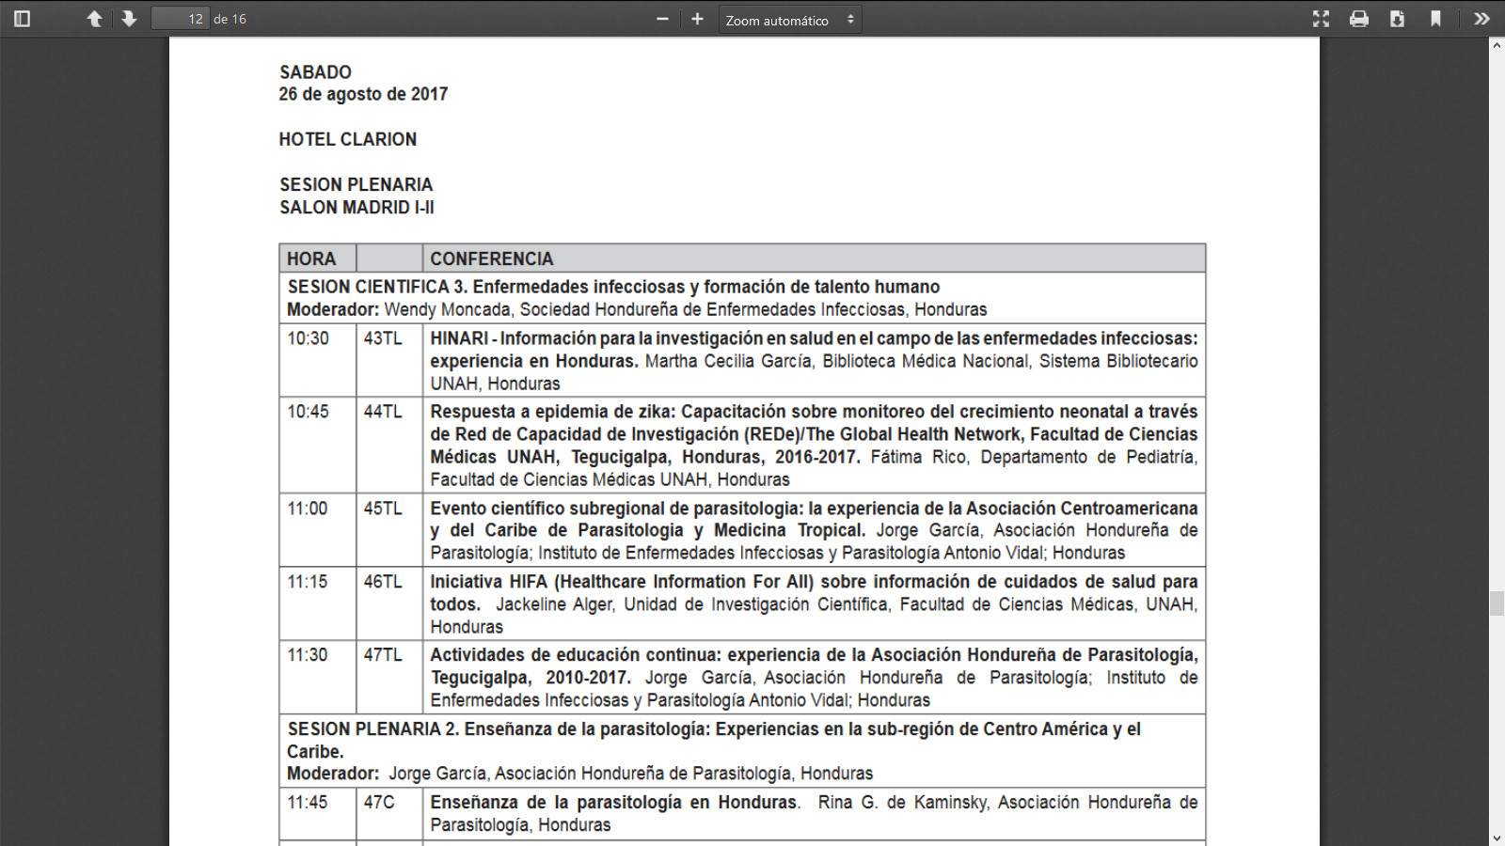

Presentation of work free "HINARI: information for the research in health: experience in HONDURAS" in the Scientific Conference XXIV and XI Congress of research in health sciences.

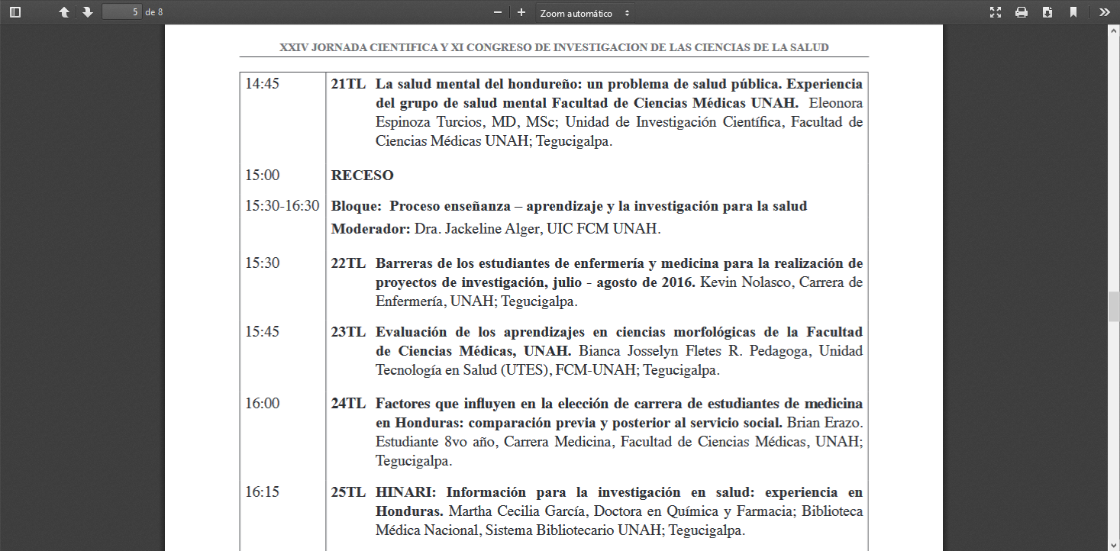
II. PHOTOGRAPHS
To. Workshop "information HINARI/RESEARCH4LIFE resources: training of trainers, aimed at librarians, held in Tegucigalpa. "
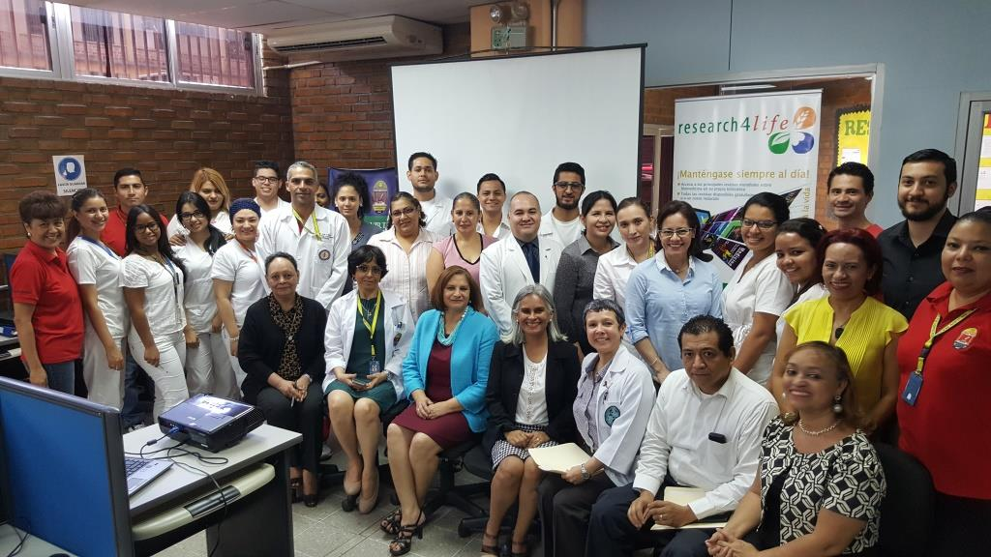
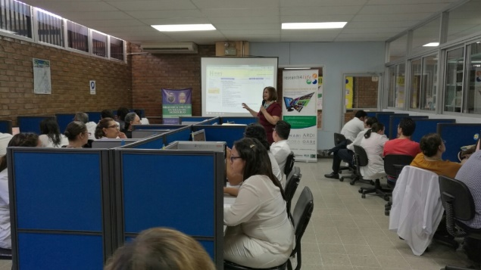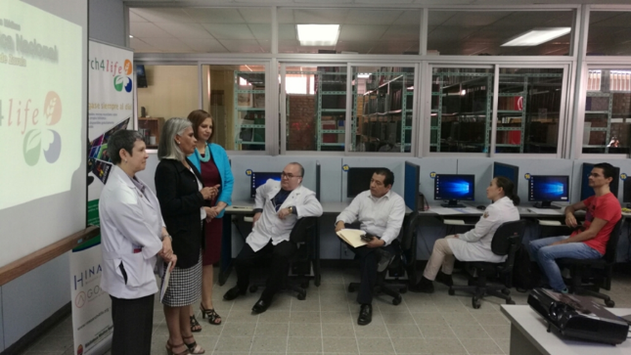
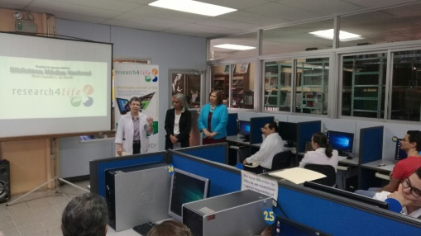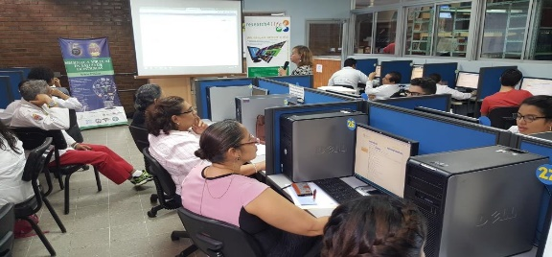

B. promotional stand of the HINARI RESEARCH4LIFE resources, XIII Congress Central American and the Caribbean
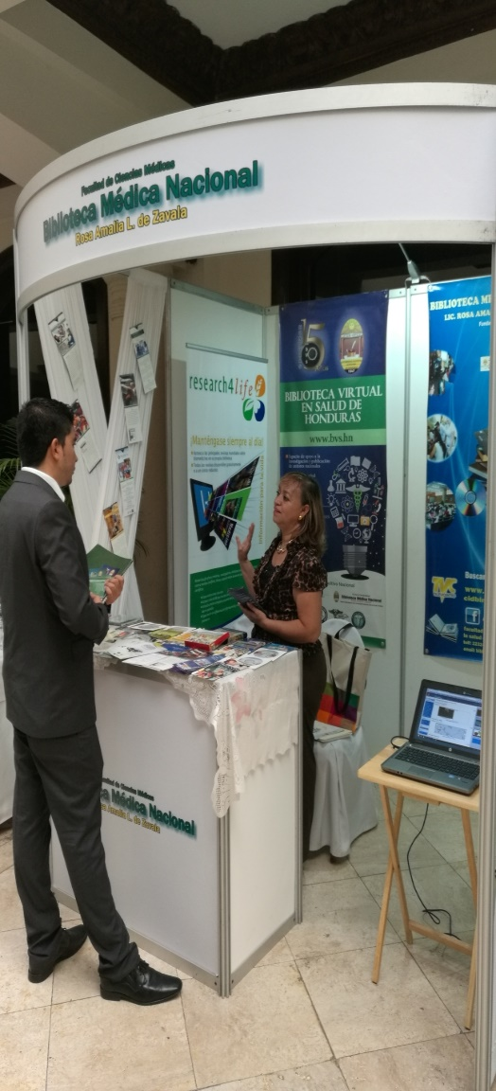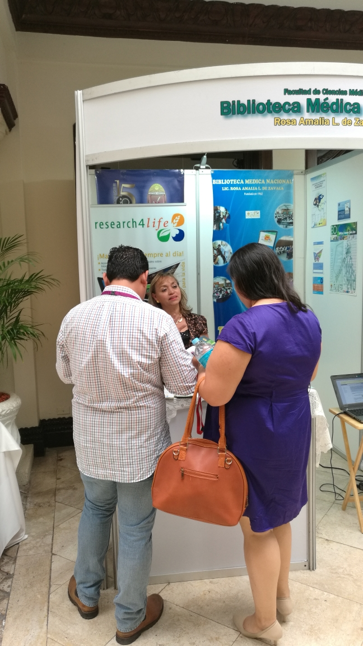
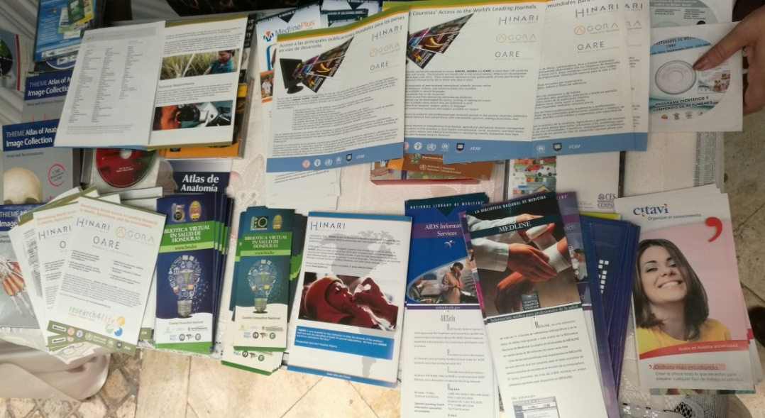

C. presentation of work free "HINARI: information for the research in health: experience in HONDURAS" in the Scientific Conference XXIV and XI Congress of research
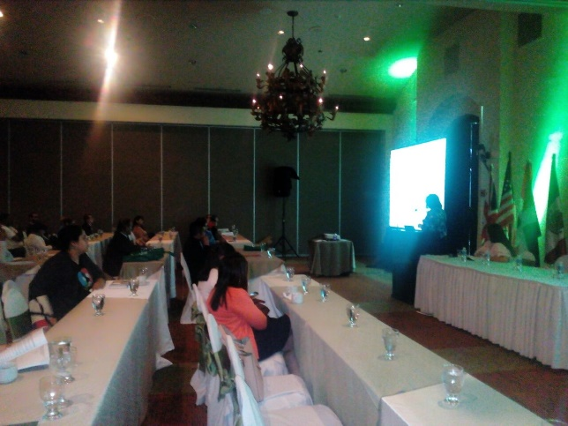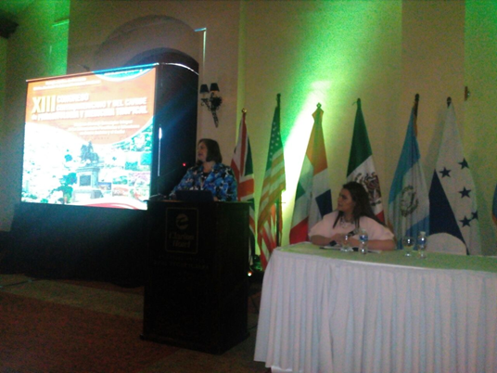

D. promotional resources HINARI RESEARCH$ LIFEstand. In Congress of Gastroenterology. Tegucigalpa
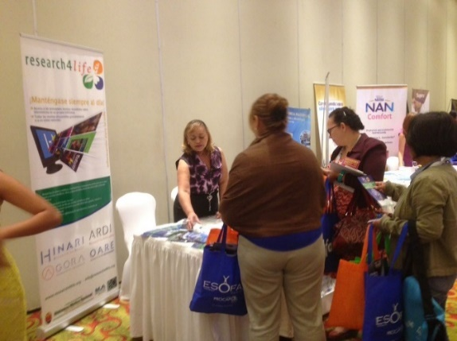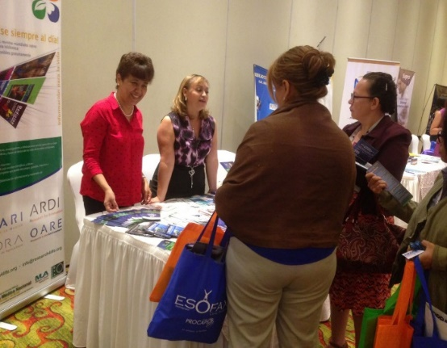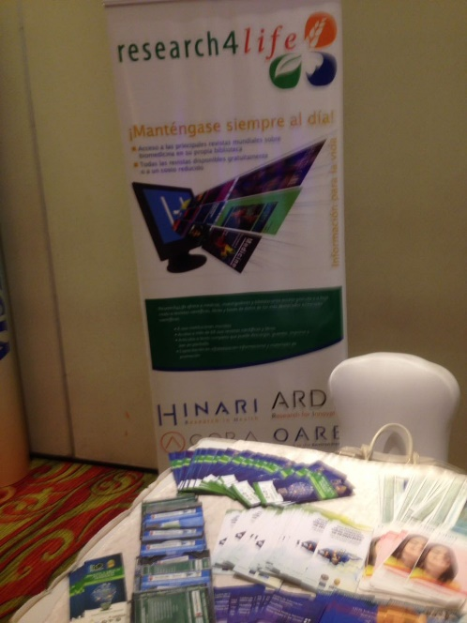

E. promotional stand resources HINARI:RESEARCH4Life in on the scientific conference XXIV and XI Congress of research in health sciences. Tegucigalpa September 27-29, 2017
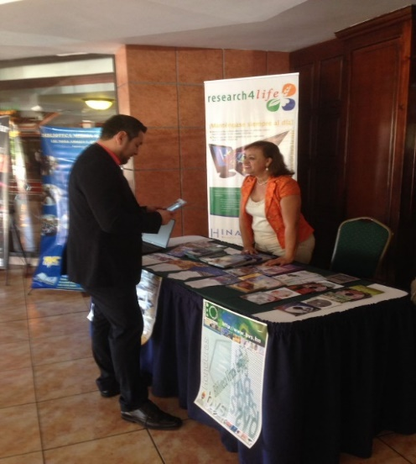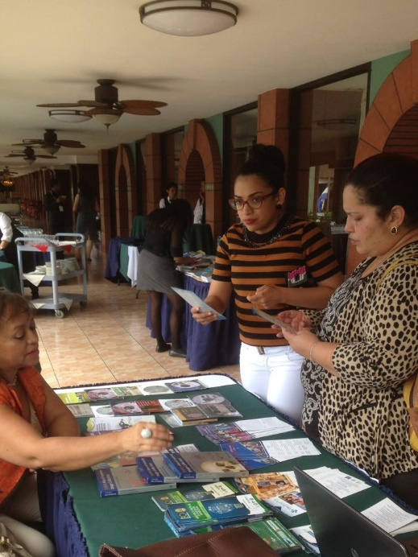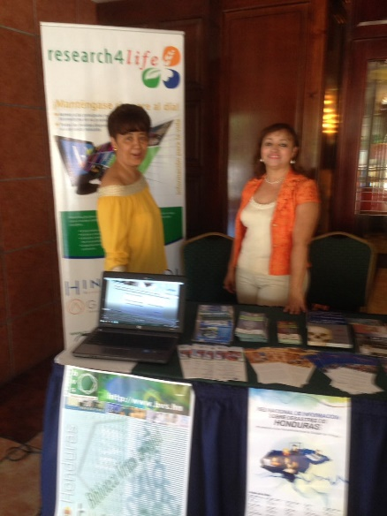
F.Taller "knowing the HINARI/Research4life information resources" in the pedagogical National University Francisco Morazán (UPNFM) San Pedro Sula
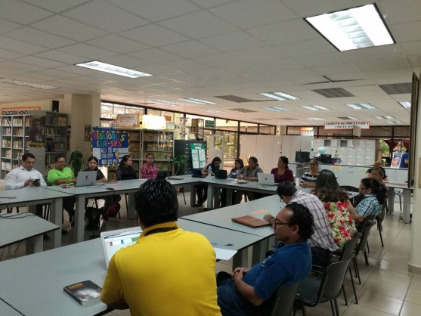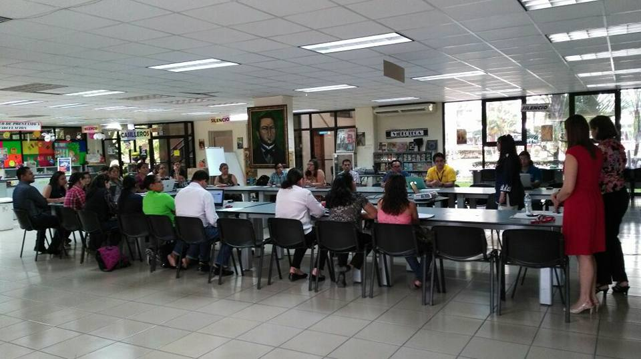

G. Workshop HINARI:RESEARCH4LIFE. Held in Tegucigalpa in the facilities of the Hospital Mary. L
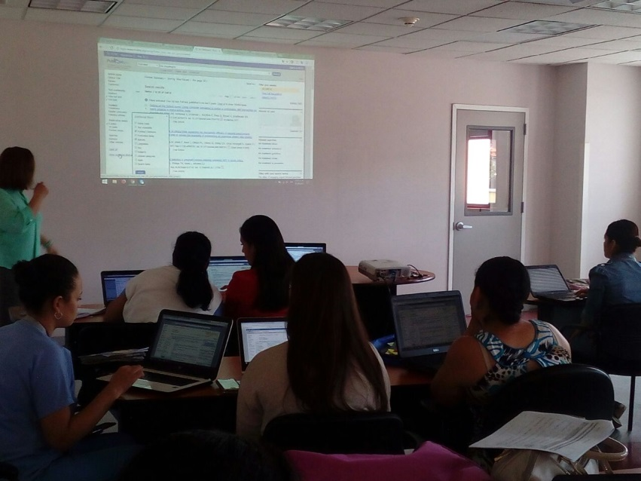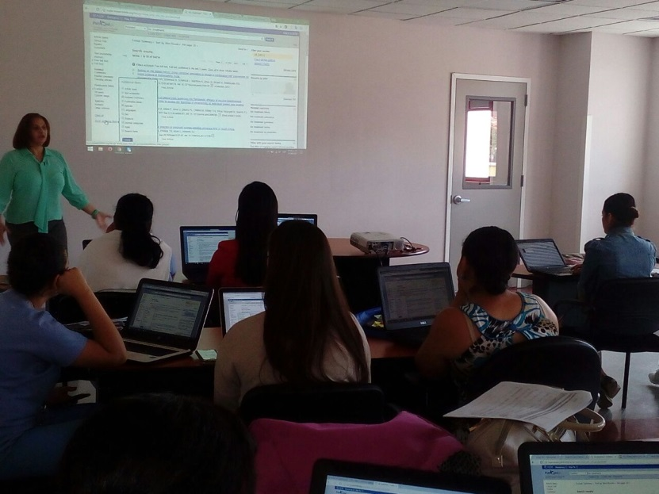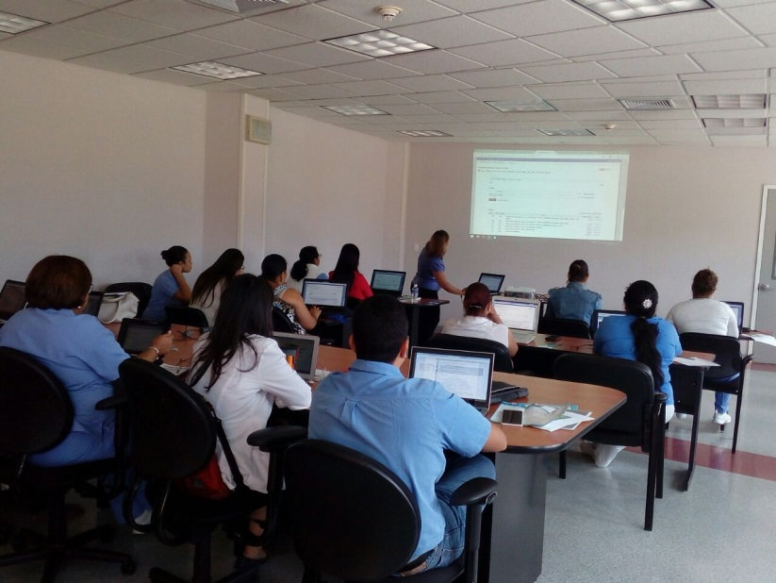
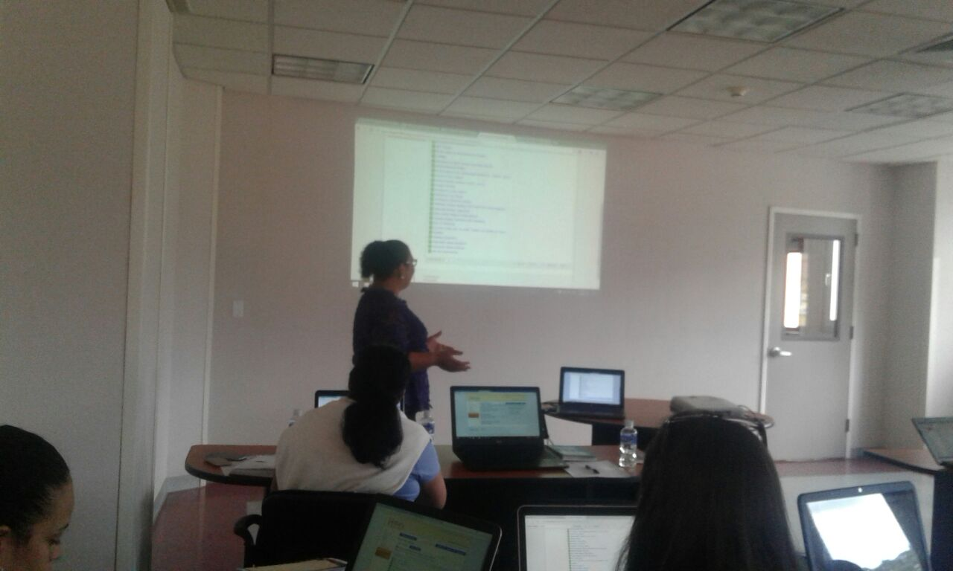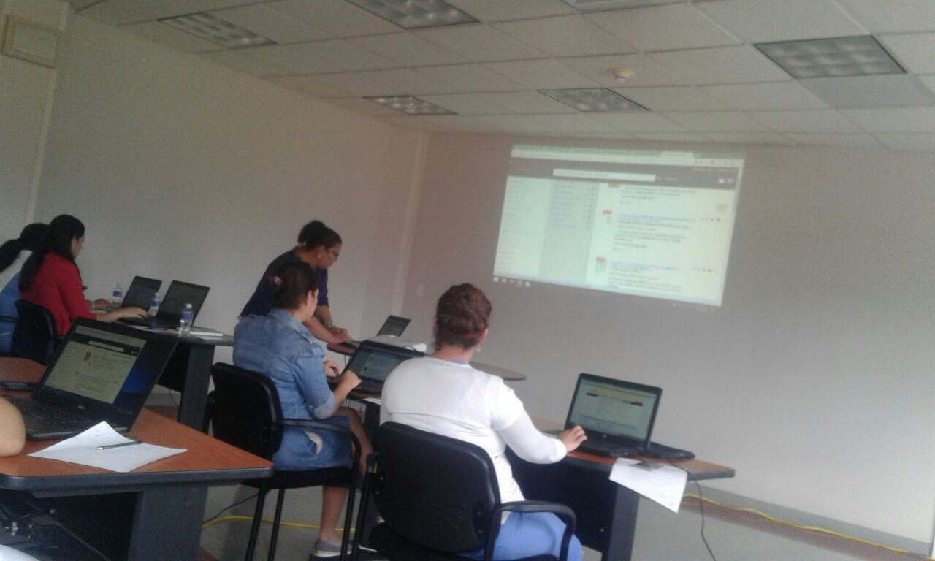

H.Taller prejornada of the medical scientific conference XXIV: Information resources for health
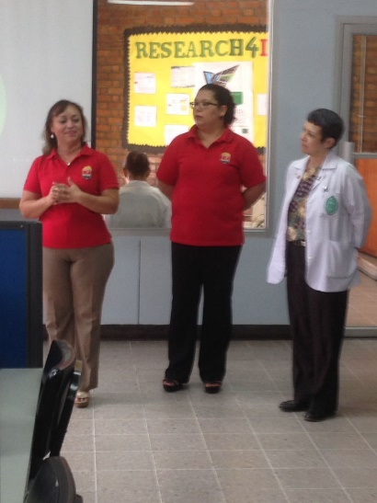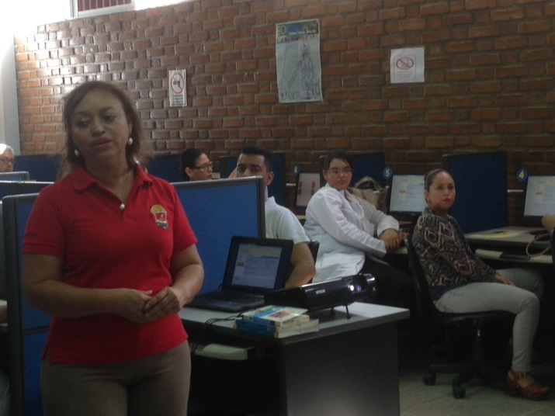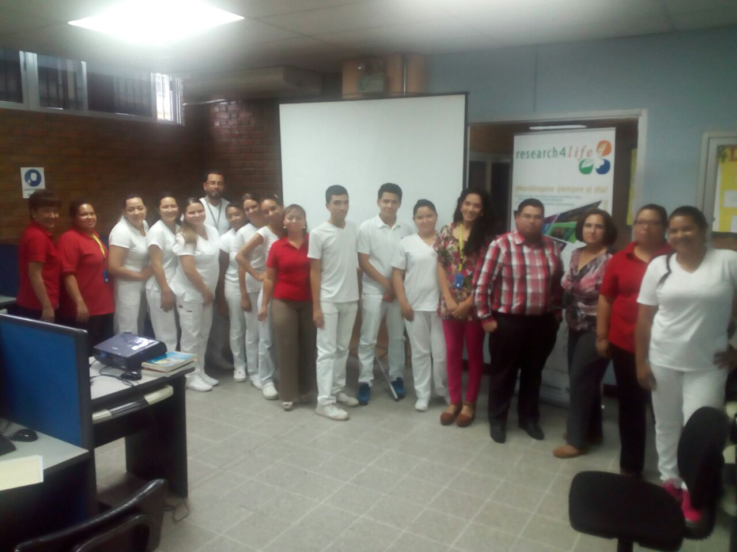

I. Workshop HINARI: information for research. 18 Tegucigalpa, October
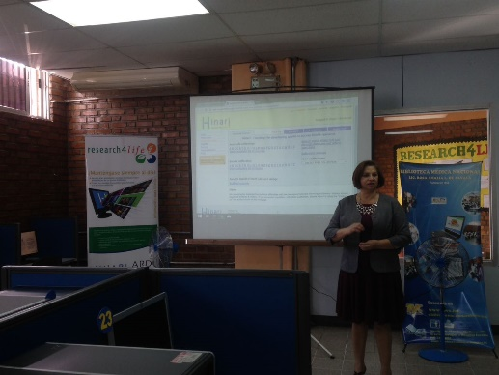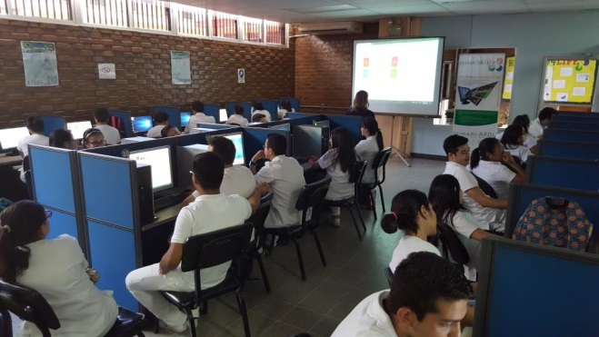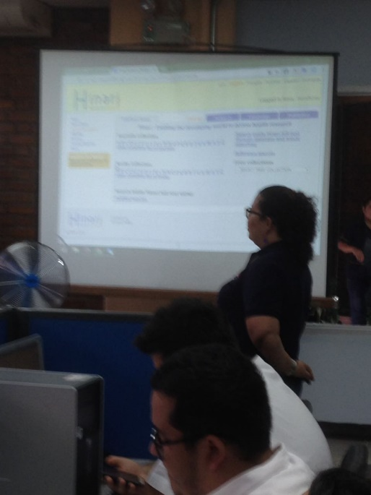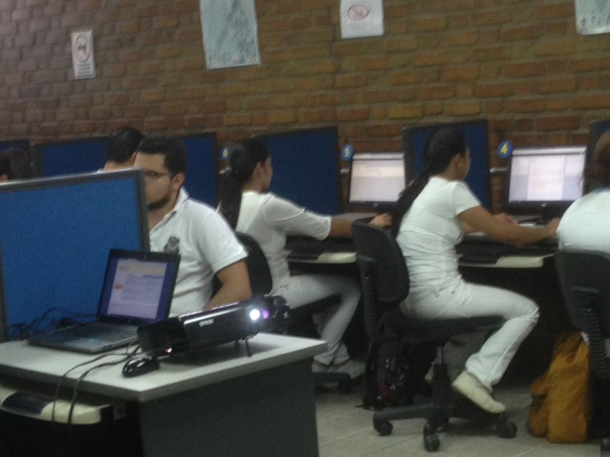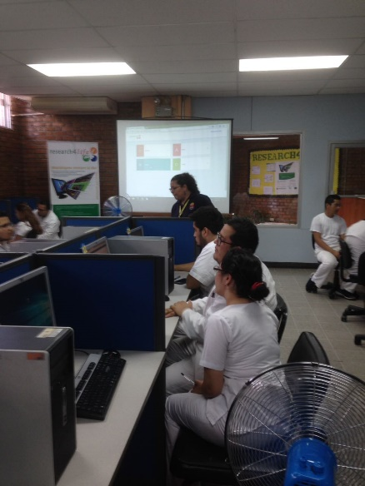

J. presentation of free work "HINARI: information for the research in health: experience in HONDURAS" in the scientific conference XXIV and XI Congress of research in the health sciences. Tegucigalpa.
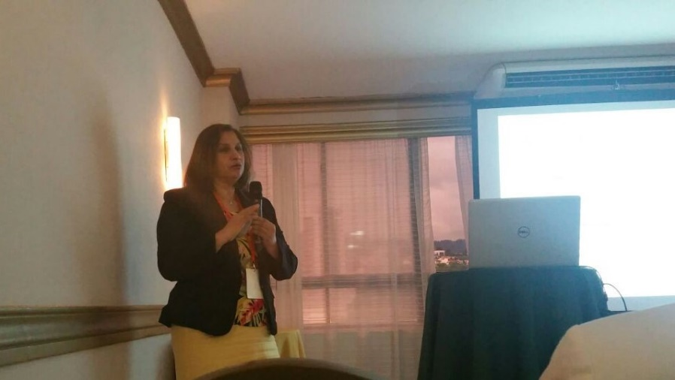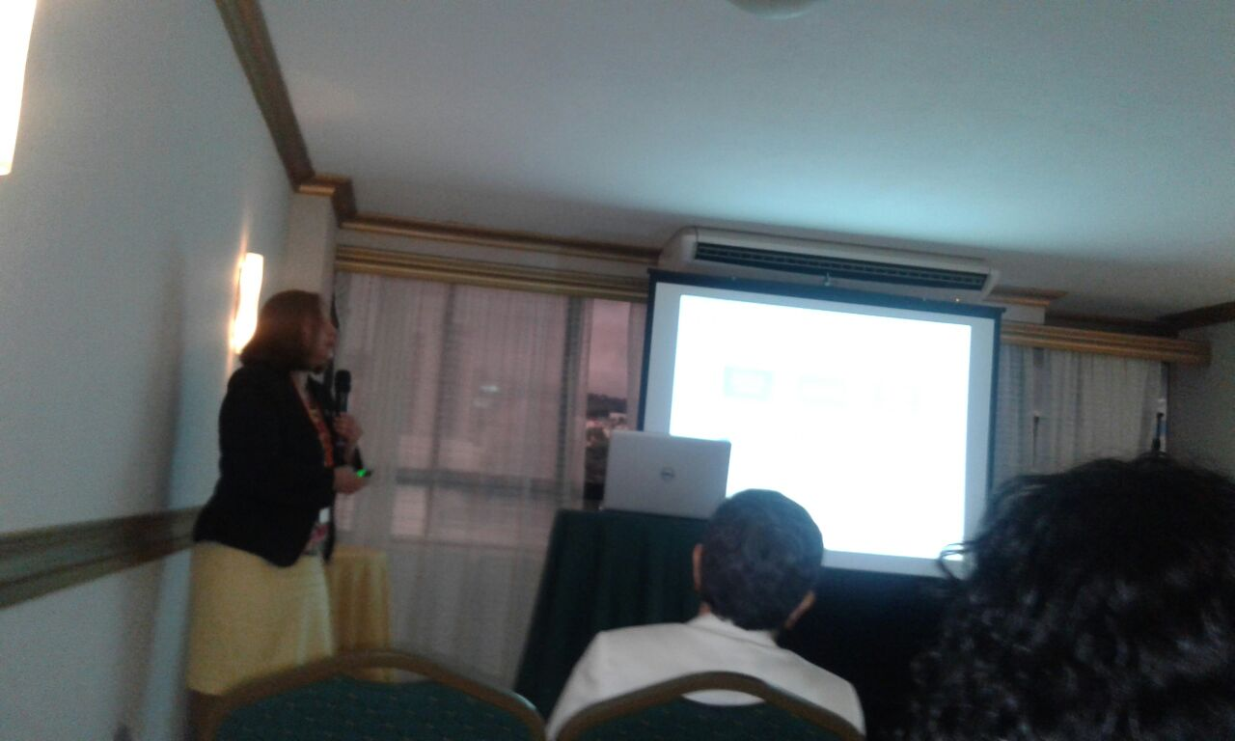

K stand promotional resources HINARI RESEARCH4LIFE, VI Multidisciplinary Congress of the graduate of the Faculty of medical sciences of the UNAH.
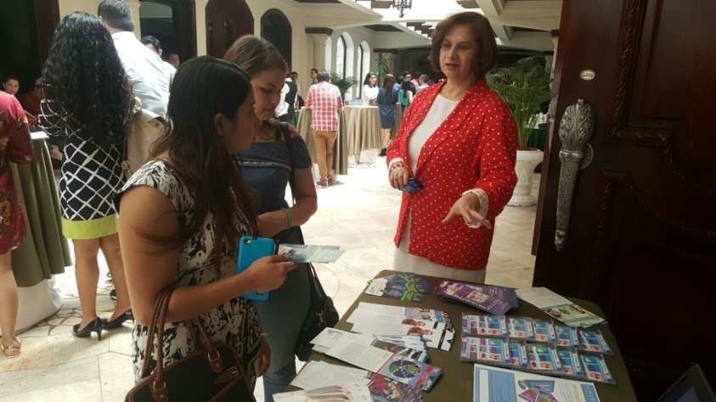
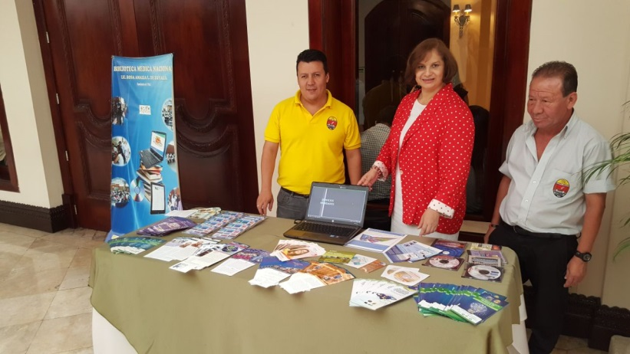

L. Workshop HINARI:RESEARCH4LIFE: information for research University national Autonoma of Honduras of the Valley of Sula (UNAH VS) 25 and 26 October in San Pedro Sula
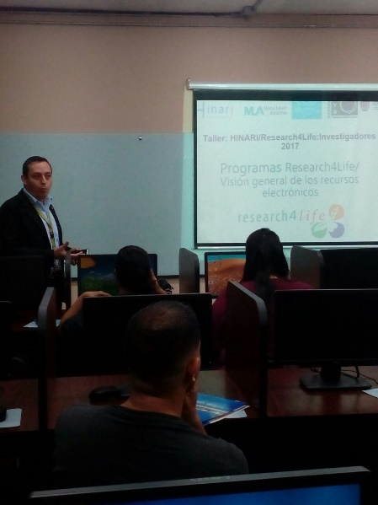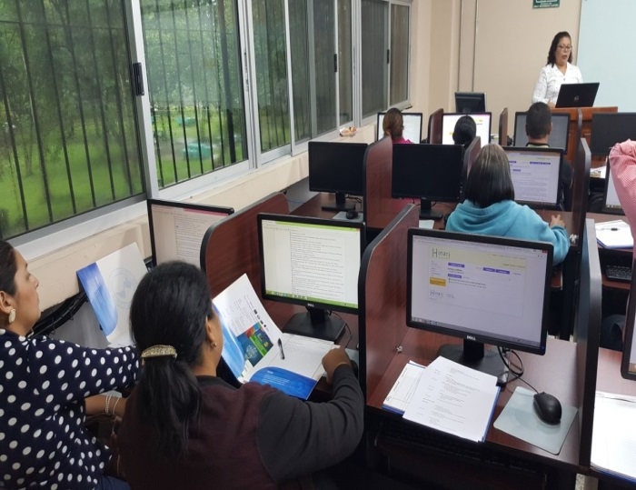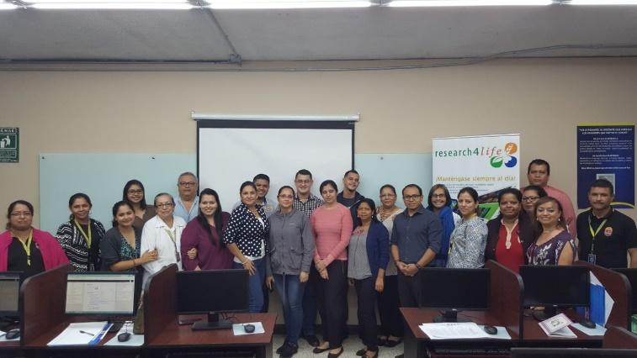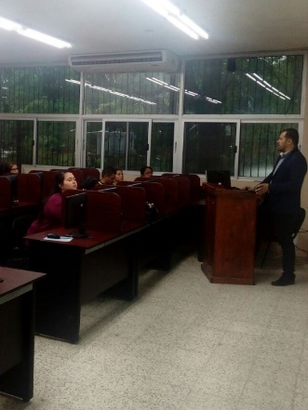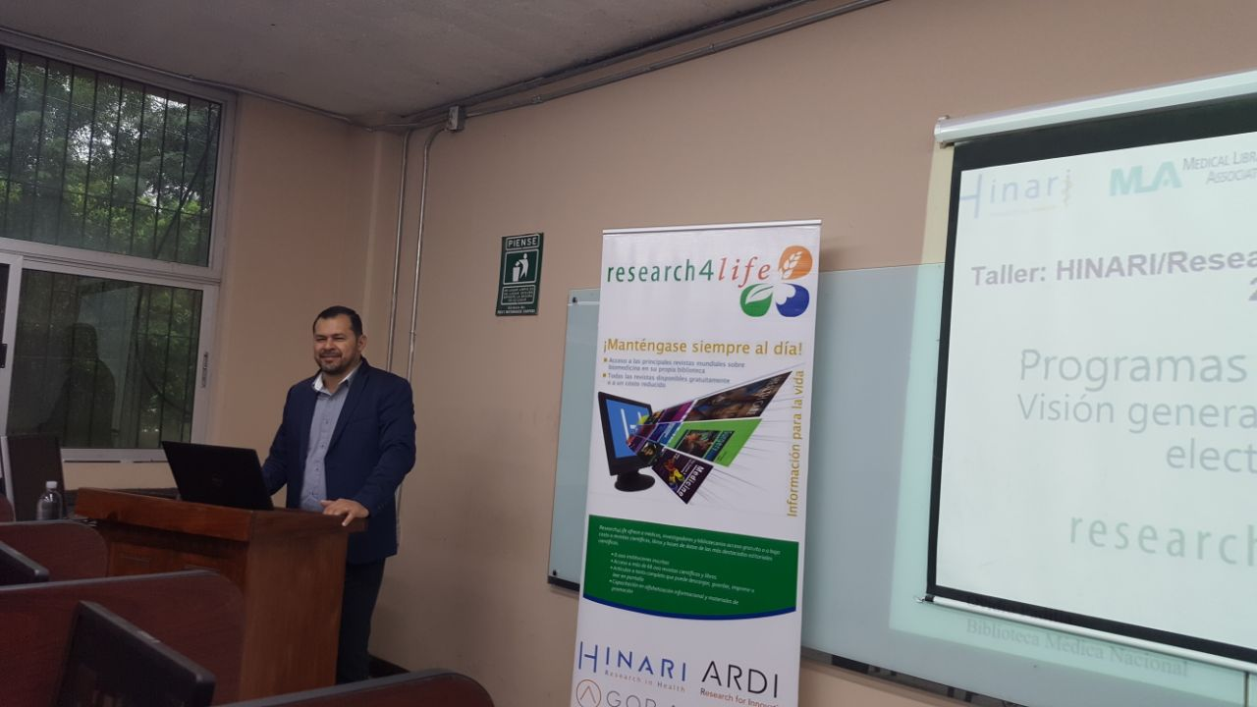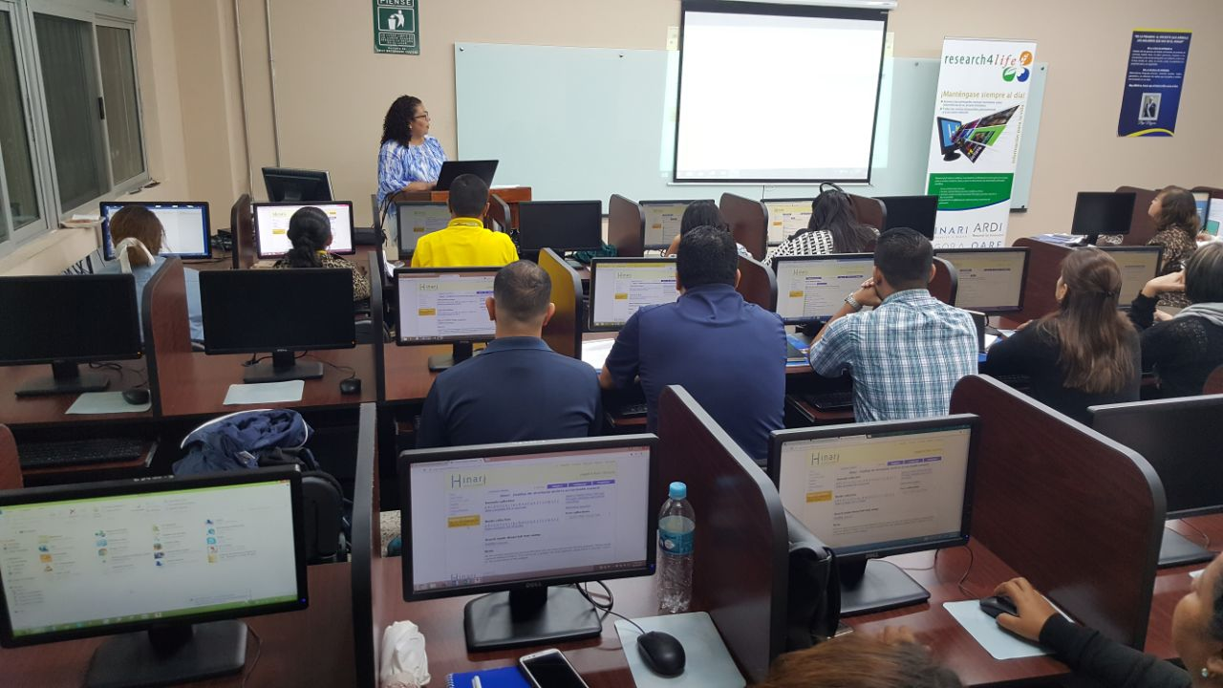

M. meeting for formation network of centers of information HINARI:RESEARCH4LIfe, national medical library, November 29.
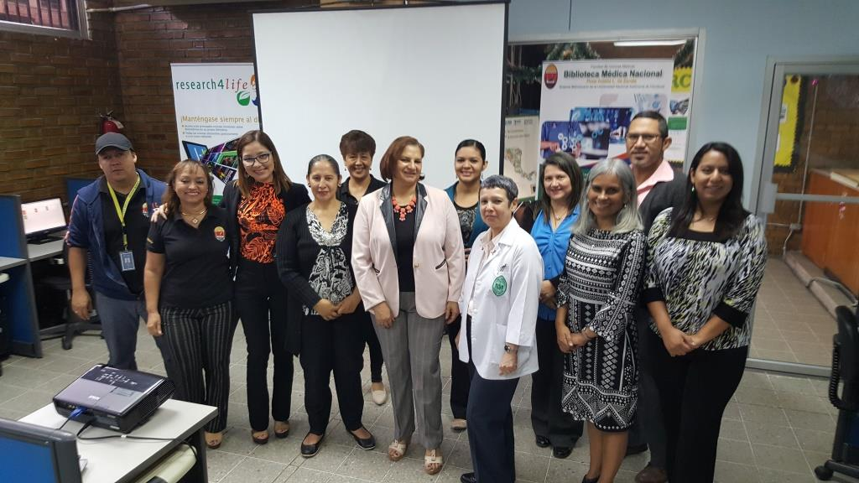 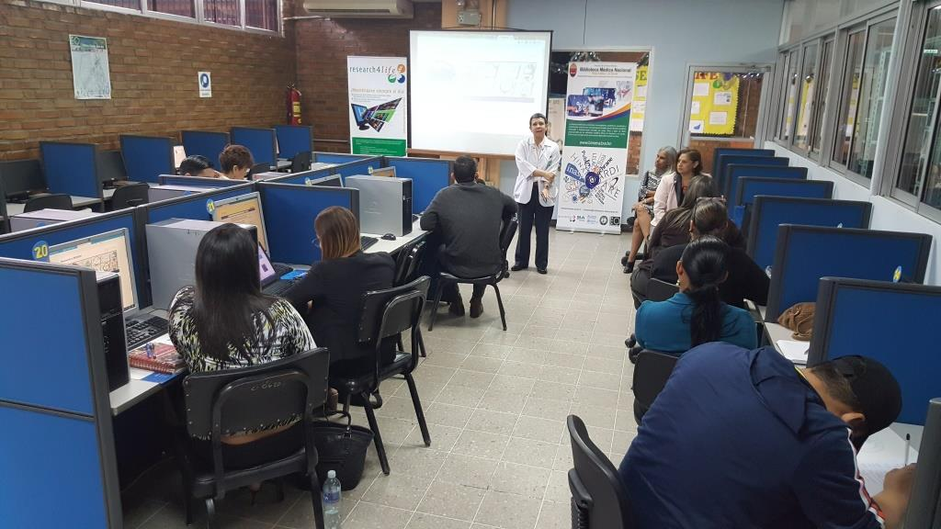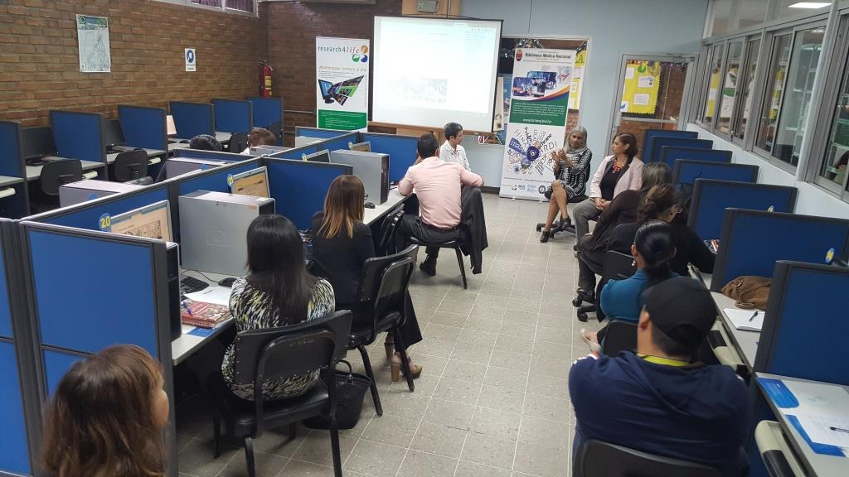
N. OTHERS: LECTURES
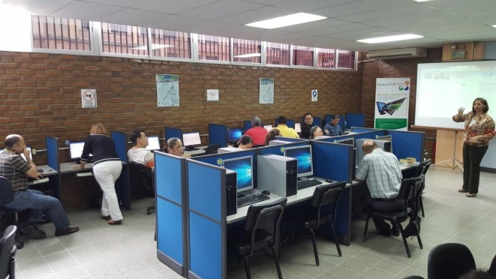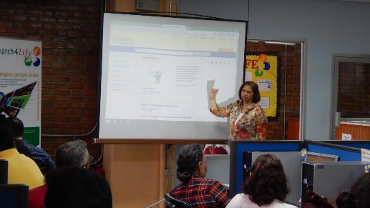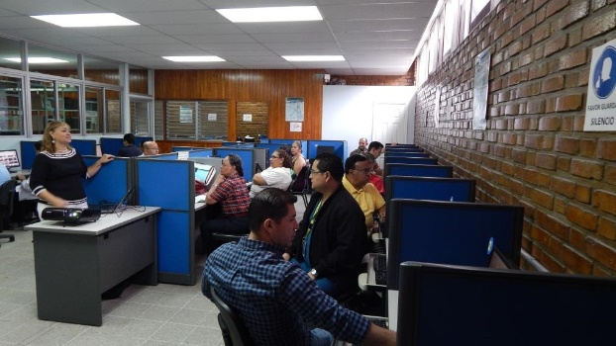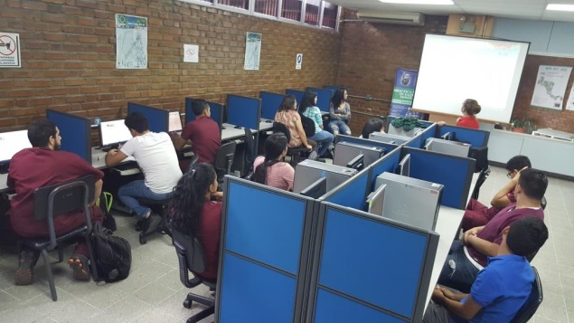
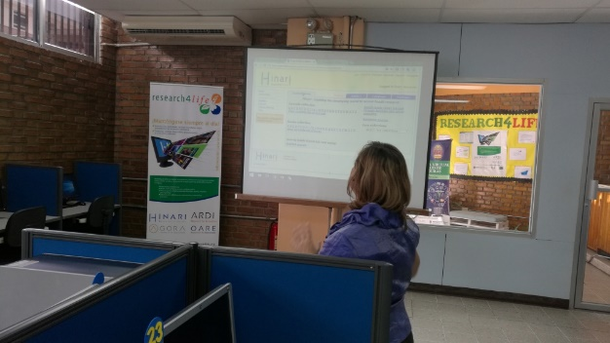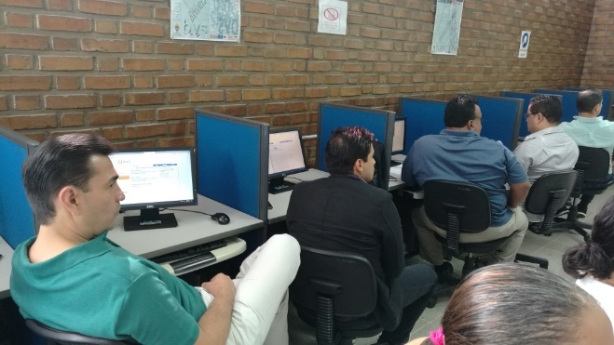
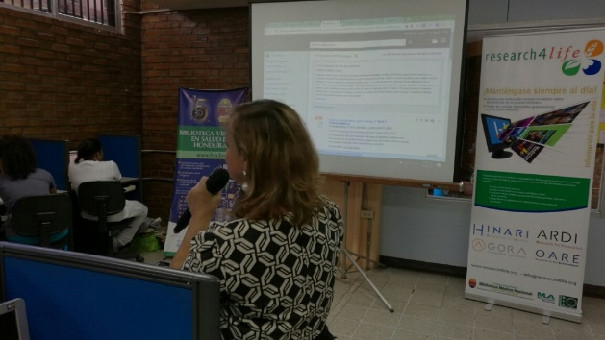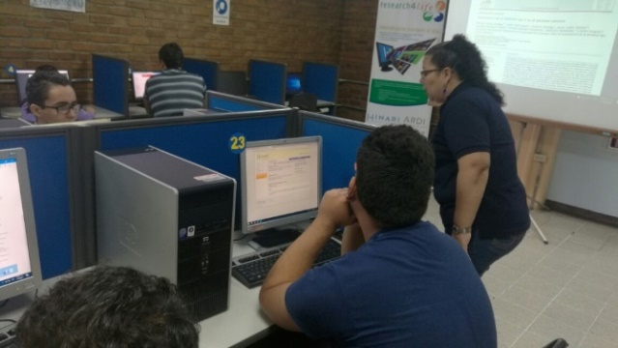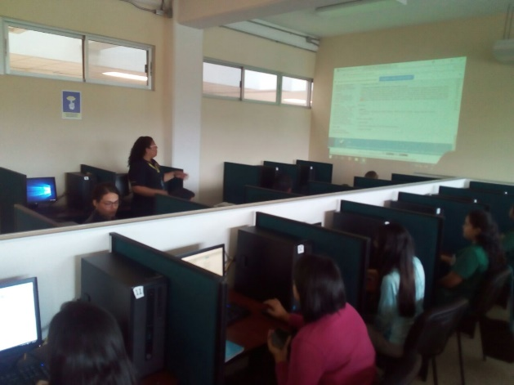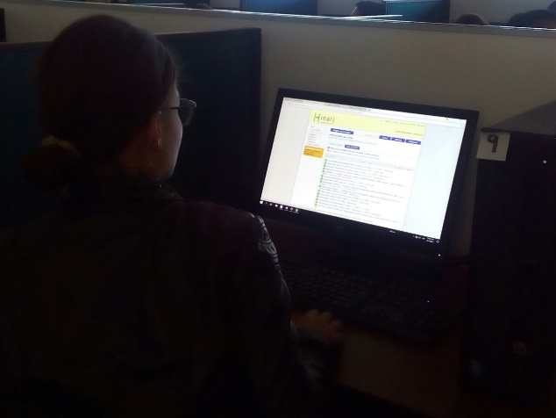
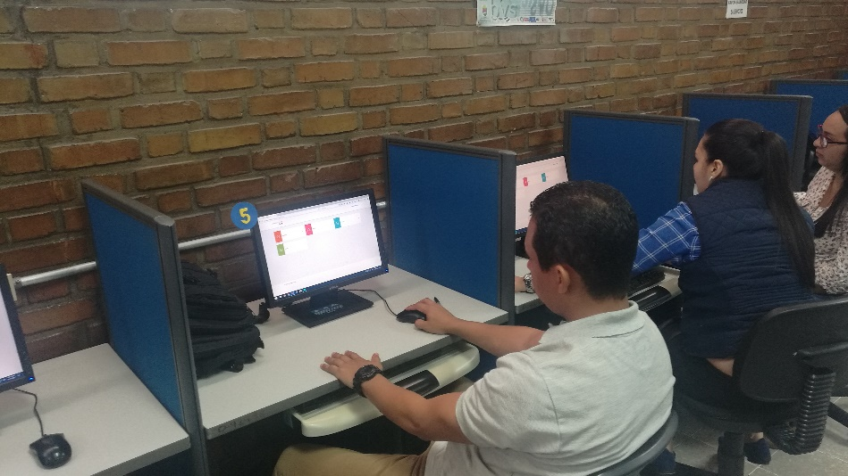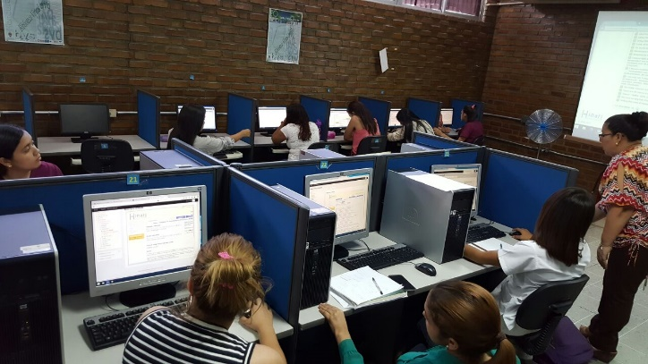

O. training in Nicaragua
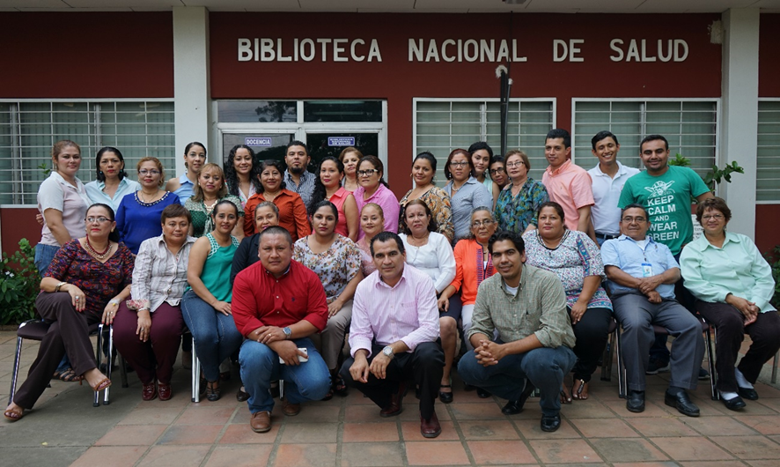
Workshop participants

PROMOTIONAL P.MATERIAL
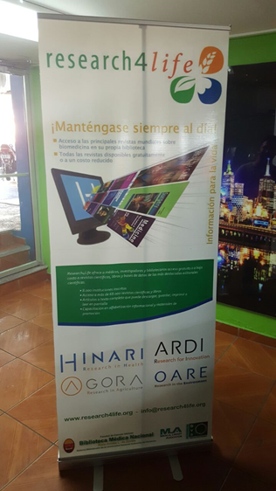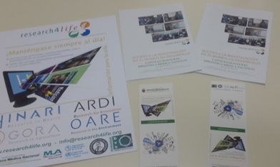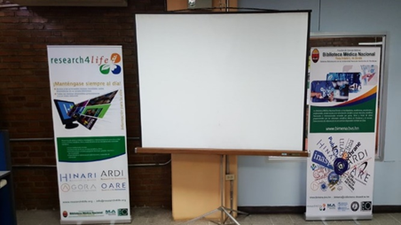
Q article published in the journal of the Faculty of Sciences Medical of the University Nacional Autonoma of Honduras. 2017, Vol.14, no. 2: http://www.bvs.hn/RFCM/pdf/2017/html/RFCMVol14-2-2017.html
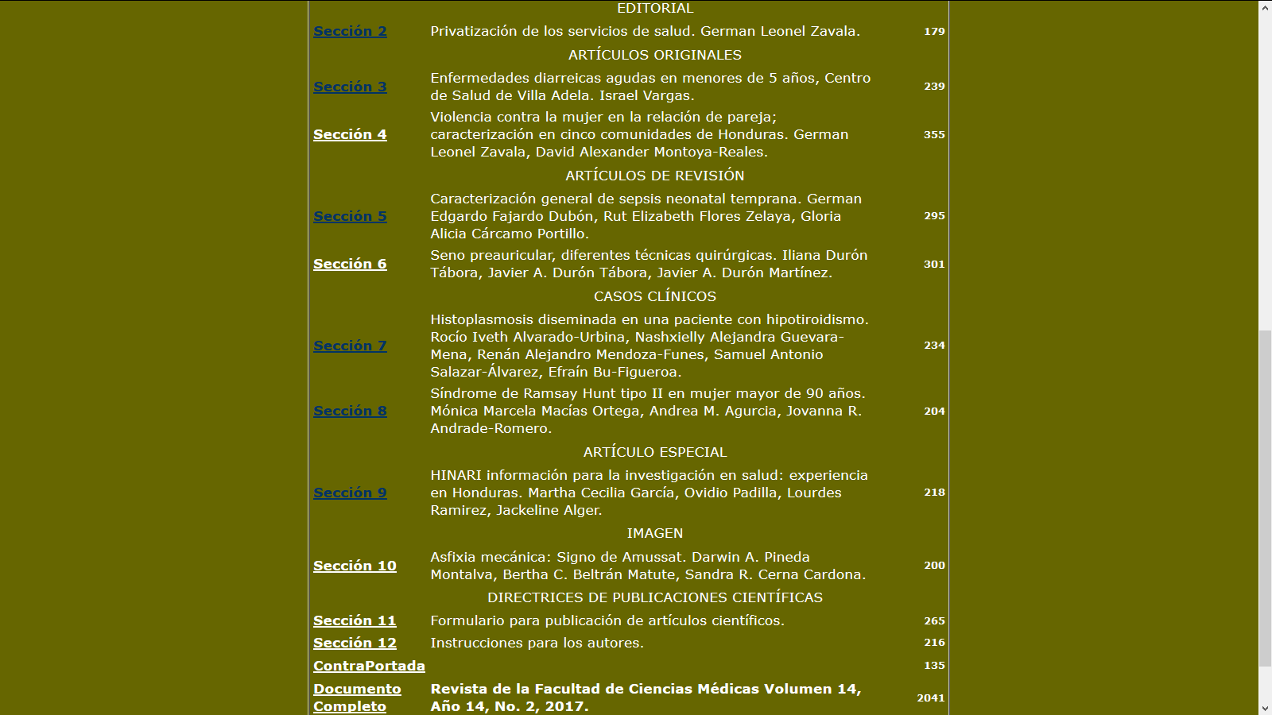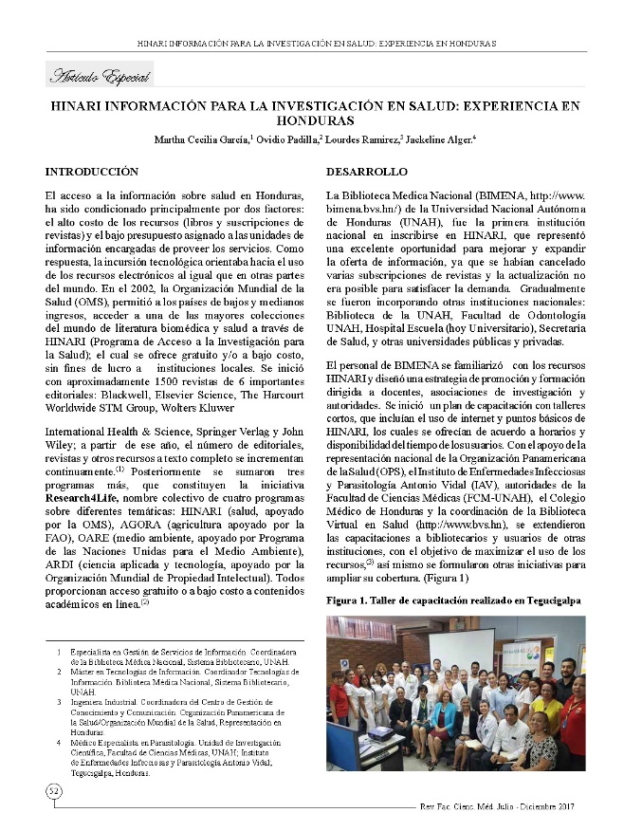

R. Virtual Classroom RESEARCH4LIFE
