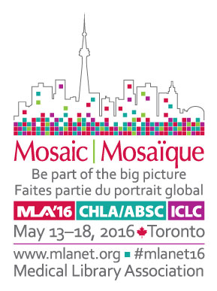

Mosaic 2016 e-Conference Registration

The e-conference provides exclusive online access to Mosaic ‘16 content through May, 2017. Online access includes:

- Plenary Sessions, keynote McGovern lecture, Janet Doe lecture, business meetings, and Wednesday morning sessions via streaming video (available within 24 hours after the presentation)
- Section programs via audio recordings synchronized with PowerPoint presentations (available within 1 week after the meeting, to allow time for editing)
- 200 posters on a wide range of topics
- Abstracts
- Access to the online content the way you want on your PC, smart phone, or mp3 device

To register, please complete the information below and return with payment:

Circle appropriate fee (amounts are in USD): | Fee | MLA ID number
MLA/CHLA/ABSC member/institutional representative | $159
MLA emeritus member | $85
MLA student member | $25
Nonmember | $235

Name:

Institution:

Mailing address:

City/State/Zip code:

Telephone: Fax: Email address:

Payment: Check enclosed (payable to MLA) Visa MasterCard American Express Discover

Name on credit card: CC Number:

Exp. Date (mm/yy): _____ Signature:

Mail: | Credit Card Payments Only
Medical Library Association | Email: naegele@mail.mlahq.org
65 E. Wacker Place, Suite 1900 | Fax: 312.419.8950
Chicago, IL 60601
Attn: e-Conference Registration

Terms: MLA agrees to provide exclusive access via Internet through May, 2017. By returning this registration form, the Site Licenses Holder agrees to safeguard and not make public passwords for access. Use of the meeting content shall be in conformity with applicable copyright laws. MLA shall do its best to deliver the programming listed above but shall not be liable for programming that is not available online due to circumstances beyond its control.

For questions contact Tom Pacetti, pacetti@mail.mlahq.org, phone: 312.419.9094, x19, or Ray Naegele, naegele@mail.mlahq.org, phone: 312.419.9094 x17.

