MLA ’19: My Case to Attend Worksheet
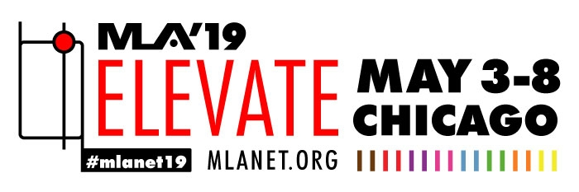

Gather the evidence to support your attendance at MLA ’19!

Possible Talking Points
My main reasons for attending MLA ‘19 are to benefit from the educational and networking opportunities, as well as innovation and inspiration at the conference.

I have been accepted to present a/an [Immersion Session, Paper, Poster, Lightning Talk] about:

My attendance at the meeting will provide me with access to sessions that will help me complete the following projects:
Enter details of upcoming or ongoing projects, plus some sessions that might help you with good ideas or colleagues from whom you would like to learn more:

I need to meet with the following vendors with whom we already do business at the MLA ‘19 exhibits because…:
Choose the most relevant exhibitors for your department from the MLA ‘19 exhibitor list and why you want to meet with them. Maybe you have an access problem they can help solve, or you want to see an upgrade of something you currently license. FOR EXAMPLE, maybe one of them is doing a Sunrise Seminar, Lunch and Learn, or Technology Showcase session that relates to your question.

I want to meet with the following potential vendors during the MLA ‘19 Exhibition because…
Choose the most relevant exhibitors for your department from the MLA ‘19 exhibitor list along with the reasons why you want to meet with them.

MLA ‘19 provides a wide range of networking opportunities allowing me to connect and develop relationships with my colleagues in the profession. Events that will help me connect include:
Explore the networking opportunities at MLA ’19 and identify those that might be the most helpful. FOR EXAMPLE: “Because I am new to the profession and to MLA, I need to connect with other newer librarians at MLA’s New Member/First Timer Program. I can also get a meeting mentor and get help with my ongoing professional development plan at the MLA Career Planning Center.”

This year’s educational program at MLA ‘19 includes sessions touching on several important topics for our library/institution. After reviewing the conference schedule, I want to attend the following sessions that will allow me to learn about best practices in…:
Explore the continuing education courses and Immersion Sessions at MLA ’19 and prioritize those that are most relevant to your role, your library, or your institution.

Other Talking Points
I believe that attending these sessions (and others) will not only give me access to the latest trends in health information but will also provide me with professional development opportunities at a very affordable cost.
I will also qualify for continuing education contact hours for nearly every educational session that I attend, which can be used for my current membership in [eventual application to] the Academy of Health Information Professionals. I am expecting to earn ______ CE hours towards my AHIP certification.
I have included a chart detailing some of the departmental needs in general, my objectives in particular, and how my attendance at MLA ‘19 can help me meet these needs and objectives.

Department’s Need: | My Objective: | MLA ‘19 offers…

Tentative Expenses Worksheet

Here is the breakdown of my approximate MLA’19 travel and conference costs:
ITEM | COST
Travel: (airfare, train, or driving mileage)
Onsite Transportation: (taxi, rideshare, shuttles, parking, etc.)
Hotel Accommodations for _____ nights: (Discounted with meeting hotel block)
Per Diem/Meals (for _____ days):
Meeting Registration (includes full access to speakers, sessions, the exhibition, scheduled group events, and a year of online access to meeting recordings):
TOTAL COST OF ATTENDANCE

